Advocate Health – Workday Bill Only App Welcome and Guide
Last Updated 09/10/2026

Contents
Welcome to Advocate Health’s New Workday Bill Only App 2
Why Are We Making This Change? 3
What’s Changing? 3
Key Information to Know 4
What’s Not Changing? 5
Expected Challenges 5
I’m a New Rep – How Do I Get Access? 7
How to Enter a New Bill Only Requisition 8
Requesting a New Item to Be Built 13
Pricing Discrepancies and How to Handle 16
How Do I Print My PO? 17
Common Support Needs – “How Do I Get Help?” 19
Navicent Cost Center Lookup 21
Bill Only Order Supplier View 22

Welcome to Advocate Health’s New Workday Bill Only App

We’re excited to welcome you to Advocate Health’s new Bill Only Requisition Application, designed to make your experience with bill-only purchasing smoother, more transparent, and more efficient. This app uses Workday’s supplier portal, where you will register for an account and have full access to enter requisitions for completed Bill Only cases, as well as monitor the status of those orders in real time as it flows through our purchase order and invoicing processes.

Why Are We Making This Change?

The bill-only process controls hundreds of millions in annual spend for Advocate, but until now, it’s relied heavily on manual entry, emails, and tribal knowledge. This led to frequent questions like “What is the status of that purchase order?” and made tracking and compliance challenging. Our new app, built on Workday, is here to standardize and automate these workflows, reducing manual work and increasing visibility for everyone involved, including you as the supplier rep. No longer will you have to email anyone regarding the status of your order; you will be able to log in and see it in real time.

We’re piloting this process at Advocate Health Navicent in Macon, GA, and Advocate Sherman, IL, with plans to roll it out enterprise-wide by mid-to-late 2027. Our goal is to ensure compliance, efficiency, and timely payment processing for all bill-only cases.

What’s Changing?

- Self-Service Portal: You’ll now be able to enter, review, validate, and monitor all aspects of the bill-only process directly in the app.
- Automated Tracking: Every requisition, purchase order, and invoice is visible in real time—no more waiting for email updates.
- Streamlined Requests: You can request new items directly through the system, with a quick turnaround for item creation and notification.
- Clear Routing: Approvals and validations follow existing flows, but with improved transparency and fewer manual steps.
- Support and Guidance: If you have questions, our Procurement Resource Team and Data Management Team are ready to help. You’ll receive ticket numbers for tracking any issues, and our teams will resolve them promptly.

Key Information to Know

- Scope: Bill only orders only. These are purchases where the PO is created only for invoicing and payment after a case. This portal is not designed to handle consignment orders. Bill only PO’s are for products specific to a case and are not for stocked inventory or consigned inventory.
- Access: You’ll receive a welcome email with instructions to register and select your authenticator app. Once logged in, you can begin entering requisitions and tracking them in real time.
- Requisition Process: Initiate requisitions by selecting your company details and entering procedure information. Approvers will verify against Epic before processing.
- Bill Only Timing: It is still expected that bill only requisitions are entered within 24 hours after case completion. We understand that requesting new items may delay, but please make every effort to enter within that time period.
- Support Contacts: For PO questions, contact the Procurement Resource Team (ASC-Procurement-Resource@aah.org). For item or pricing issues, reach out to Data Management (data.management.team@aah.org).
- Compliance: All bill-only items must be in the item master to order. Validation against Epic remains required, and governance and clinical approvals are unchanged.
- Feedback: We value your input! Please share feedback on the landing page experience and any suggestions for usability improvements.

What’s Not Changing?
- Governance, approvals, and clinical validation remain intact. The use of products still falls within the policies of Advocate Health regarding the use of non-approved or non-contracted items. Every item is subject for review before approval of order.
- No backdoor purchasing paths—compliance is still a priority.
- The process for handling new item requests and value analysis committee requirements continues as before.

Thank you for partnering with us during this transition. Our team is here to support you every step of the way. The following page details the support model in place as you begin working in this new app.

Expected Challenges

The Advocate Health team has worked hard to customize the app to meet the needs of all involved. That said, there are some current known limitations at go-live. Please read these carefully:

- Supplier Reps Who Sell Products from Multiple Suppliers
  - An example here is a representative who sells products across multiple manufacturers, such as Stryker, Smith and Nephew, Depuy Synthes, and Medtronic.
  - For each unique supplier in Advocate Health’s supplier master, will require you to have a unique email for login. We understand that this can be a challenge, especially if each individual manufacturer does not give you an email address.
- Unique Requisition, PO, and Invoice Required for Each Supplier
  - In the instance where the procedure uses products across multiple suppliers (as defined by the current setup in Advocate Health’s item master), the supplier representative must enter a unique requisition for each supplier.
  - An example – you are a representative for Stryker. Unfortunately, many products in the Stryker catalog are required to be spread across multiple Stryker divisions – Stryker Spine, Stryker Instruments, Stryker Ortho, etc. If the case you finished contains products that cross those suppliers, you will have to enter a requisition for one, submit, then log out and log back in as the other supplier and enter another requisition. Invoicing will need to follow the two or more distinct purchase orders created through this supplier-specific process.
  - If you feel an item is set up under the wrong supplier, submit a request to data.management.team@aah.org to review and make changes to simplify.

I’m a New Rep – How Do I Get Access?

If you are a new rep or determine you need a new account in our portal, follow these steps:
- Provide the following information to your Advocate Health contact within the OR, Cath Lab, etc. that you are servicing:
  - Your Name
  - The supplier/manufacturer of the products you are submitting a bill only for (e.g. Johnson & Johnson, Medtronic USA, Smith and Nephew, Etc.)
  - Your business email address
  - Your best phone number
- The Advocate Teammate emails vmo@aah.org with this info, putting #billonly in the subject line. This helps with prioritization and routing to the correct team. Note: emails directly from the rep will be denied. This needs to come from an Advocate teammate.
- VMO will build the representative as a Supplier Contact in Workday.
- A Workday Security admin will enable the Supplier Contact for Workday’s portal.
- This will generate a welcome and registration email to the representative.
- If you do not receive the welcome email, use the following link to gain access: Workday Central Login
- The rep completes the registration, creating their portal account.
- A Workday Security admin then will add the rep to the correct security group, giving the rep access to the Bill Only Requisition Application - Built on Workday app.
- The rep will receive an email indicating their account is ready for bill only requisitioning.

How to Enter a New Bill Only Requisition

Bill Only Application – Step by step instructions:
- Login to Bill Only Application as a Supplier using <supplier user id> <password>

- Search for task “Bill Only Requisition Application - Built on Workday.”

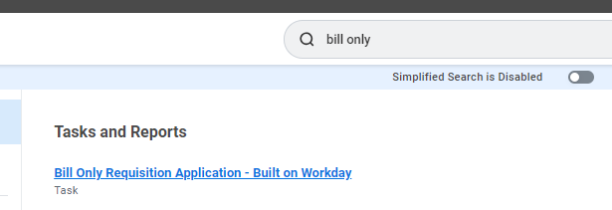

- Click on the task opens the Bill Only Requisitions home page.
Two actions can be performed by the Supplier.
- Click on Create Requisition button takes Supplier to Create Bill Only Transaction data entry page.
- Supplier can view the past transactions in the “All Past Requisitions” grid. It provides the complete lifecycle status of Bill Only transactions here.
  - Requisition Status
    - “In Progress” means the transaction is created by the supplier.
    - “Successfully Completed” means transaction is approved by the OR Clerk and ready to be sourced to PO.
  - Purchase Orders and Status
    - “Approved” means PO is approved and ready to be issued
    - “Issued” means PO is issued
    - “Fully Invoiced” means Invoice is fully invoiced.
    - “Unpaid” means supplier payment status is not paid.
    - Note: Receiving status is not a valid status for Bill Only Transaction
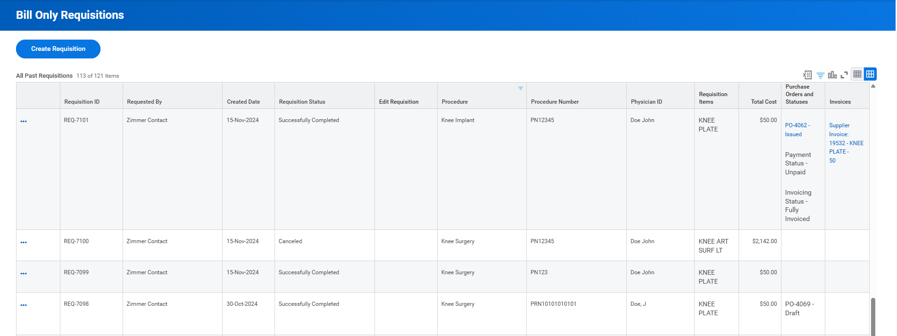

- Click on “Create Requisition” button to start Bill only transaction.

Enter header information – Company, Ship To, Department

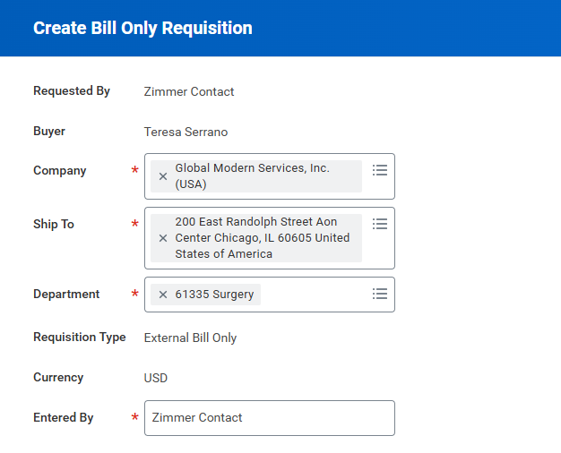

Contact your local facility rep for this info. This is important for proper accounting and budgeting.

Company = Three-digit number (e.g. 145)

Ship To = Will default in. No need to enter.

Department = Also called “Cost Center”. It is recommended to use the last five digits of the 12-digit center string. See link to obtain the five- digit codes. Page20

Entered By = Will be your name. Do not change.

Additional procedure date, Procedure Number, Procedure, Patient ID (patient 3 initials) Medical Record Number (Note: MRN will not be saved in delivered requisition page), Physician Name,
Procedure verified by – The Advocate teammate who signed off on the Bill Only sheet.
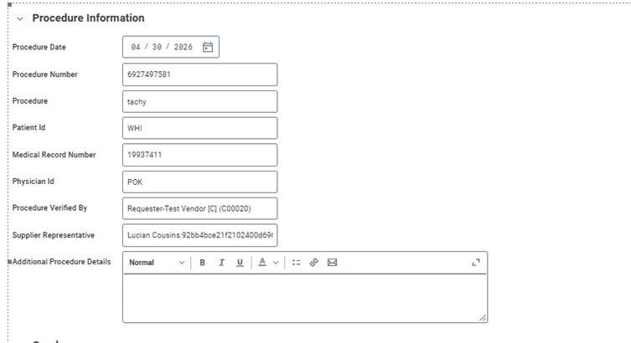

Item: Enter items consumed in procedure. You can search using Item Description, MFG Number or Supplier Item Number. Search with and without special characters (like dashes, dots, etc.) for best results.
Quantity: Enter the total quantity consumed in procedure.
Lot Number: Enter the applicable Lot Number. Enter NA if not applicable.
Serial Number: Enter the applicable Serial Number. Enter NA if not applicable.
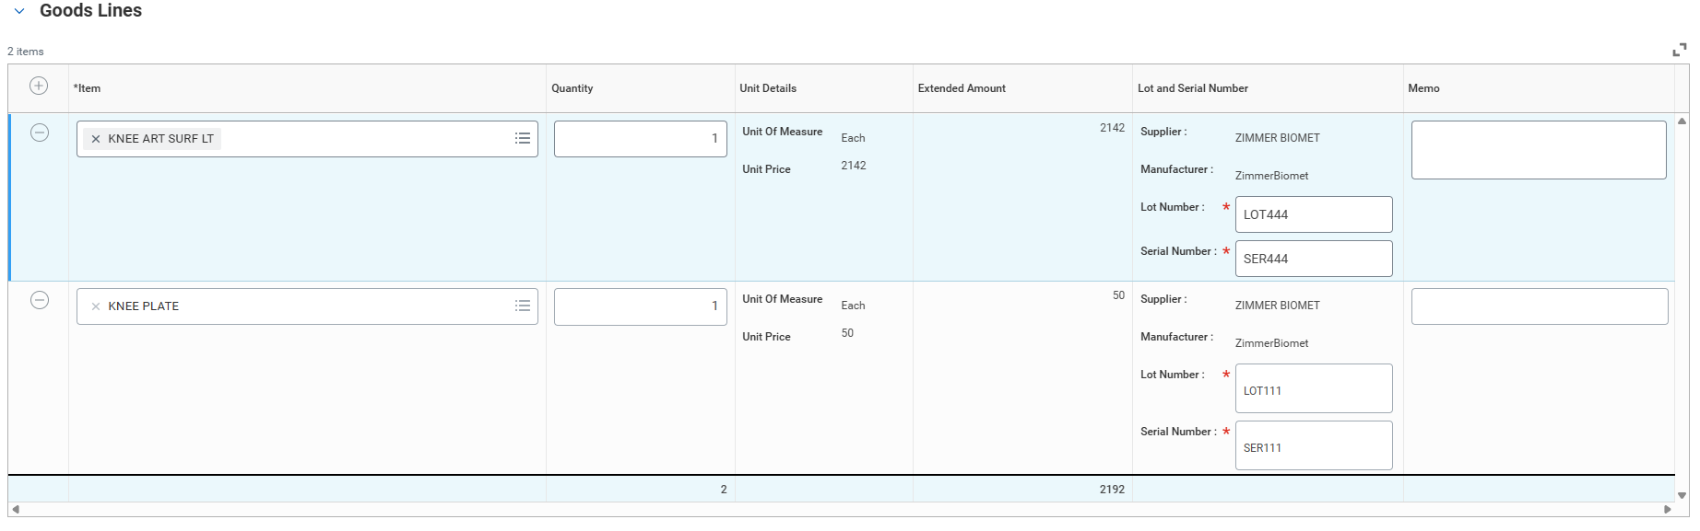

If item is not available for choosing, complete a New Purchase Item Request (see section of requesting a new item in Table of Contents)
Upload procedure attachment(s) of the bill only sheet/sticker sheet/case sheet. This will be used during internal approval to make sure all items are accounted for and match Epic documentation. – # of attachment up to 5, valid format is pdf’s or image can be uploaded.

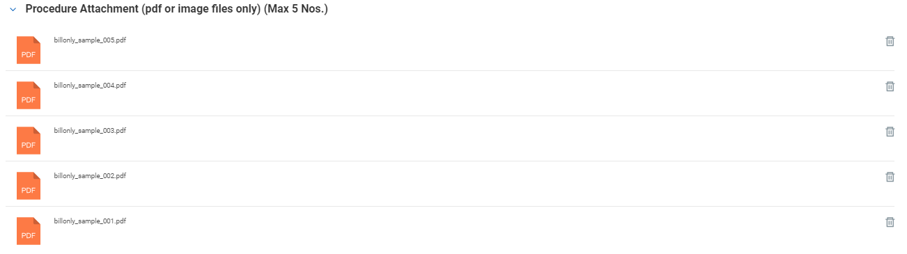

Declaration – Check the attest button, verify certification date (defaulted to today’s date)
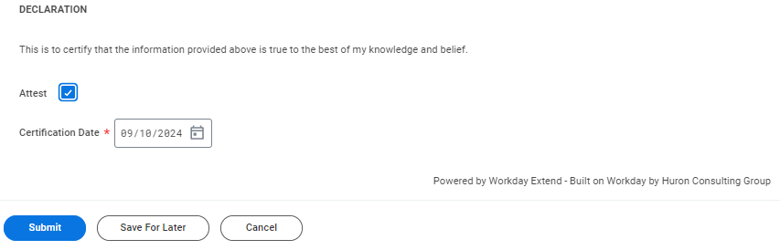

Actions
- Click on Submit button completes the transaction.
- Click on Save for Later if there is a need to get items created, supplier is not ready to submit the transaction, etc. Supplier can login later and select the transaction to take further action from “All Past Transactions” grid on the home page.
- Click on Cancel button cancel’s the transaction.
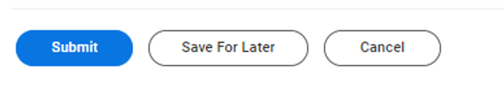

Click on Submit button successfully creates the Bill Only transaction. (Note: The Requisition number). Click takes you back to home page to view the life cycle status of the Bill Only transaction. Requisition status is “In Progress” meaning the requsition has been successfully created and ready to be sourced to become PO. You can check the Requisition status in the “All Past Transactions” grid of the home page.
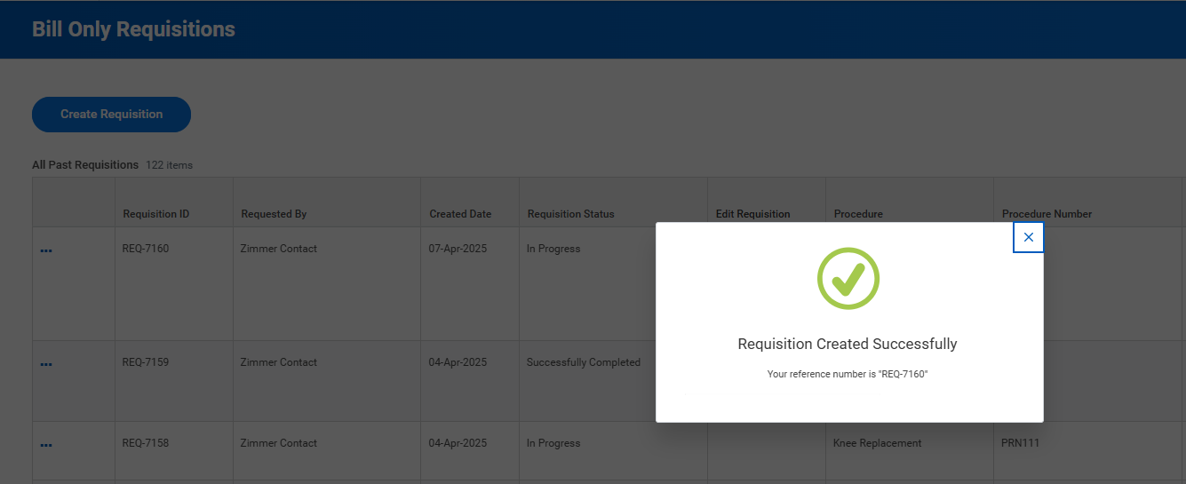

- View “All Past Transactions”

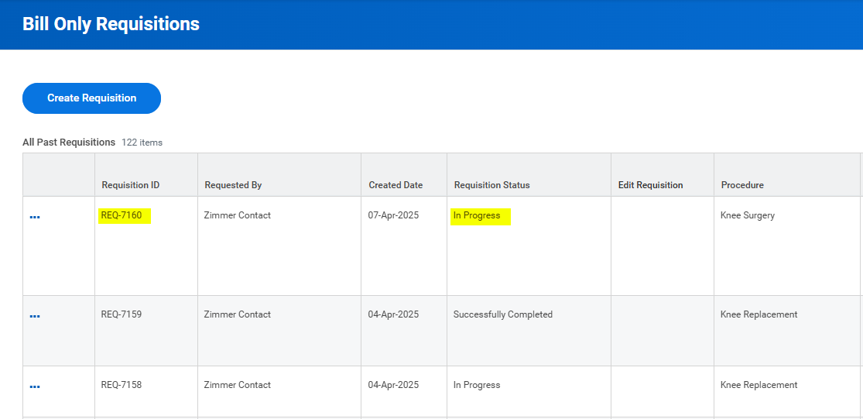

You can view requisition by clicking on the … dots
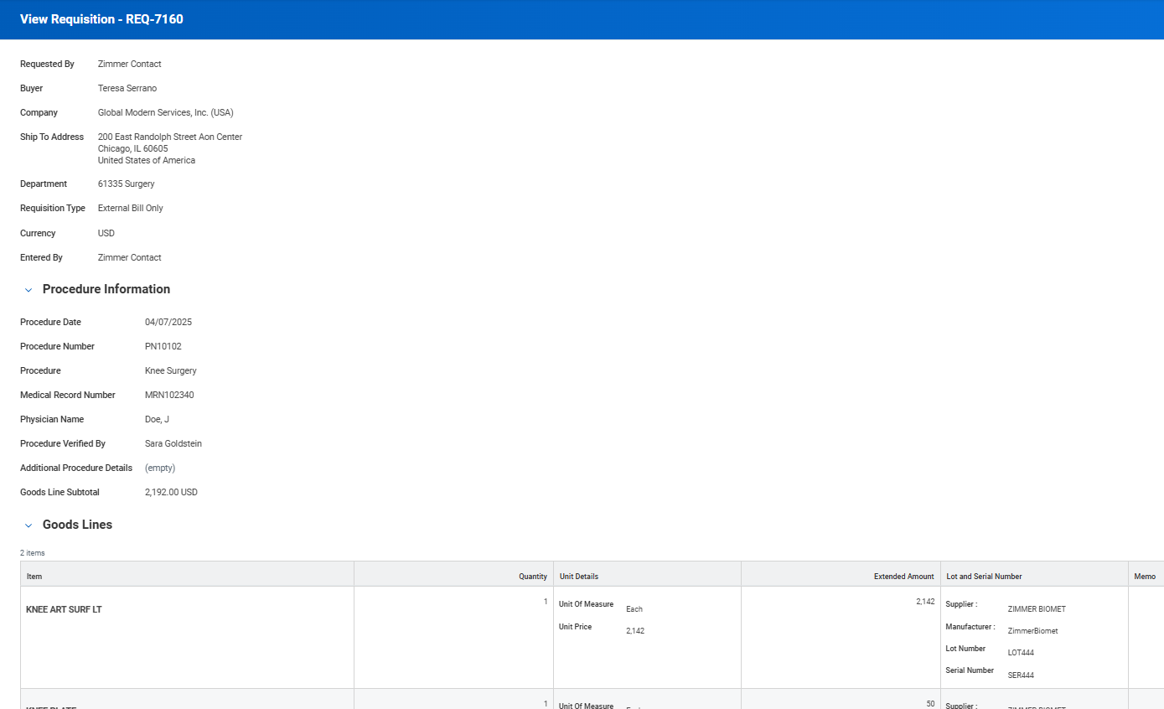

Requesting a New Item to Be Built

- To request a new medical item, begin by searching “Request New Purchase Items in the Workday Search Bar
- Select the “Request New Purchase Items” Task.
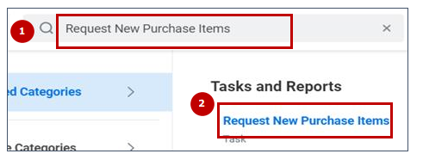
- Select the company for which you are requesting and clear out the Request Location field (it isn’t required and sometimes creates errors). Choose ‘New Purchase Item Request Bill Only’ for the Purchase Item Request Type. The ‘Pricing Effective Date’ will be current date.
- Click OK to access the questionnaire.
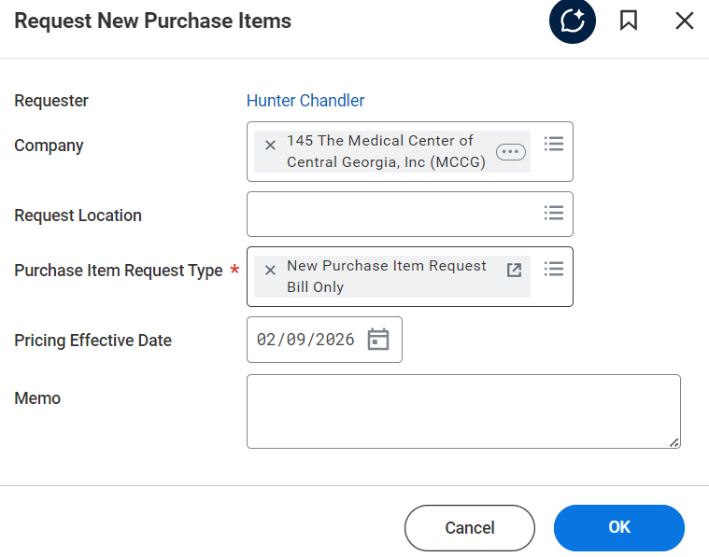
- On the Questionnaire tab, simply enter your name, company, and an email address. Attach a scan of the bill only sheet here. This is required.
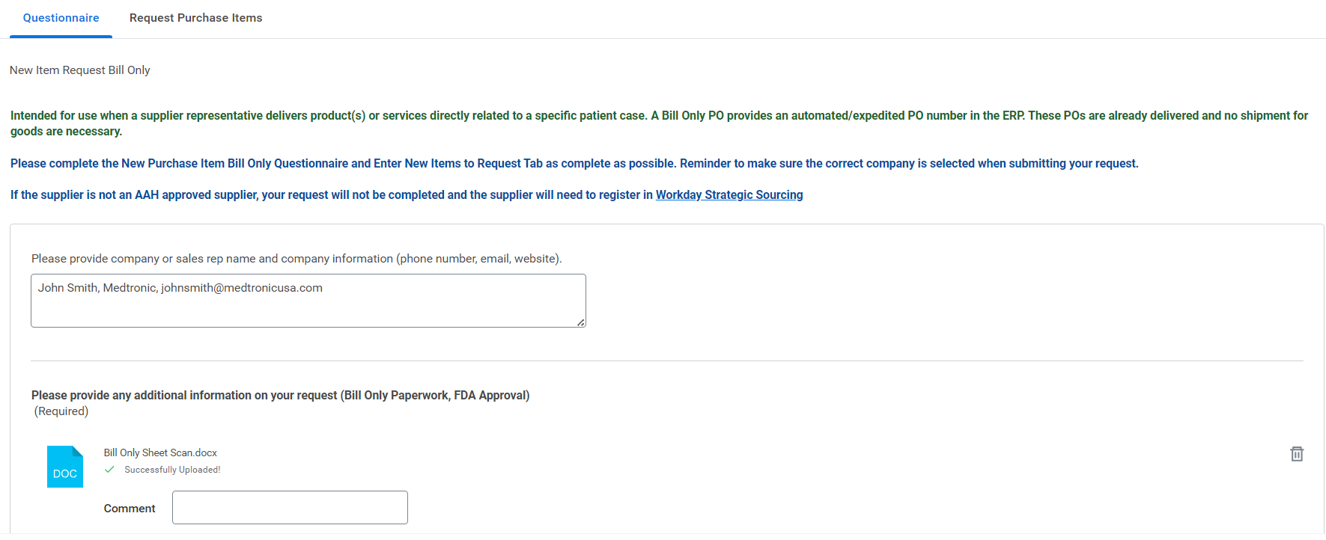

- Now click the Request Purchase Items tab to enter information about your items.
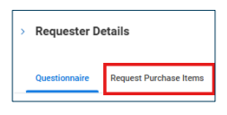
- Click the ‘+ ‘sign to add items. (You may click on the ‘ – ‘sign to remove any errors)
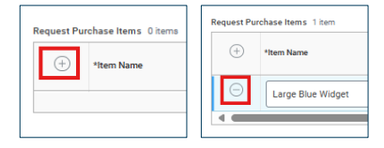
- Required Fields and tips on each:
  - Item Name – Just give a reasonably strong description of the item
  - Item Description – can be same as Item Name
  - Spend Category – Choose Supplies: General – Medical (SC71741). Tip: just search “supplies general” and hit enter - it will be the first selection. The Advocate Health master data team will improve this later.
  - Manufacturer – Search the manufacturer of the product. The Advocate Health master data team will fix anything wrong here; just get close.
  - Manufacturer Part ID – Be as accurate as possible here.
  - Base UOM – the lowest UOM in the packaging string (probably EA)
  - Default Ordering UOM – the UOM that you sell the product to us in
  - Currency – always USD
  - Default Ordering Price – the price of the Default Ordering UOM
  - Preferred Supplier – search for your supplier’s name and press enter
  - Preferred Supplier Item ID – typically the same as the Manufacturer Part ID. This is the part number on the PO line.
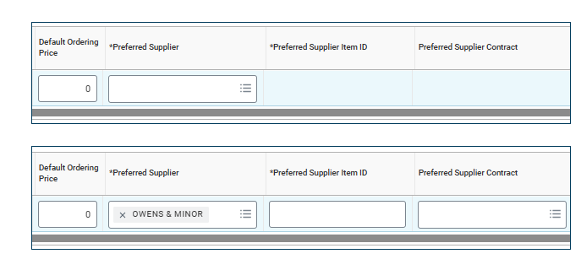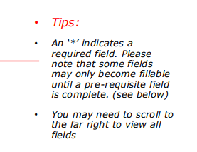
- Click ‘Submit’ when complete
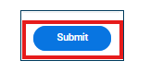
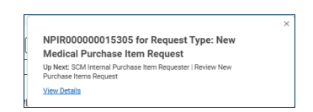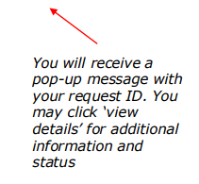

Pricing Discrepancies and How to Handle

When entering orders, the price in our Workday system will occasionally differ from the information that the representative has in their information. While pricing differences often have complex root causes, these are the general scenarios:

  - Supplier Rep’s Price > Workday Price
    - The best practice is to email data.management.team@aah.org.
    - Advocate’s pricing team will review your recommended price and update the price in the system, or they will inform you that the price in the system is accurate per contract.
    - Once updated, the rep submits their request with no issues.
    - If the rep submits the requisition without aligning the price before submission, Advocate Health’s normal pricing match exception processes will catch these. This potentially delays the most efficiency payment turnaround time.
  - Supplier Rep’s Price < Workday Price
    - The Advocate approver of your requests is empowered to reduce the price to the lower price stated on the scan of the sticker sheet/bill only sheet.
    - These will not create match exceptions and will match and pay in a timely manner.
    - Again, emailing data.management.team@aah.org is the primary mechanism to get a price updated permanently in Advocate Health’s Workday item master.

How Do I Print My PO?
- Log in and navigate to the Bill Only App.

- On your landing page, find the Requisition and Purchase Order you’d like to print. Click on the blue hyperlink to the issued Purchase Order.

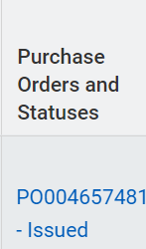

- At the top of the page, look for the blue Purchase Order number and find the Related Actions button (three dots in a “Twinkie” shaped button). Click Related Actions.

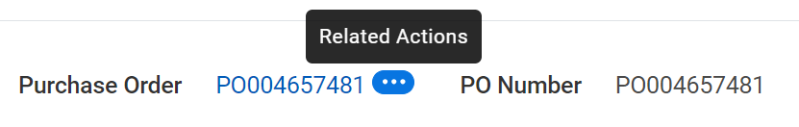

- Select Purchase Order > Printable Version

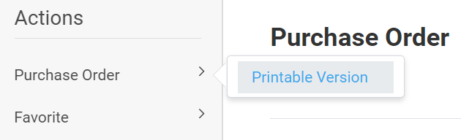
- Click OK
- Wait a few seconds and click Refresh. When complete, you will see a blue link with a PDF file that you can now download and print.

Common Support Needs – “How Do I Get Help?”
 | Trouble finding an item. Question about an item. Question about price. | Need to request a new item. | Question About a Purchase Order. | Difficulties with Logins, App Access, Technical Issues. | Mismatch or Disagreement on Product Usage (Requisition does not match Epic documentation).
Example(s) | • Pricing on Workday item doesn't match your expectation.  • Item set up under the wrong supplier.  • Part number, description | • Trying to add items to requisition and cannot find. | • Request to change something about a PO after there is an existing PO in Workday | • Cannot log in.  • Unable to find Bill Only App once logged in. | • Disagreement on quantity used between in-room documentation and what representative enters.
Contact | data.management.team@aah.org |  | ASC-Procurement-Resource@aah.org | Open service now ticket using this link. | Work directly with local site contact. Resolved between requisition Approver and supplier rep.
Who Should Request Support? | Advocate Health teammate (preferred) or Supplier Representative | Supplier Representative | Advocate Health teammate (preferred) or Supplier Representative | Advocate Health teammate (external reps don't have access) | Rep works with local site contact collaboratively.
Important Information | Manufacturer Part Number and Manufacturer. Details about what is wrong. | Refer to section in this document of how to request item. | PO Number. Question or request to change. | Name, Supplier, Issue at hand, Screenshots | Case Number, Requisition Number, Case Date, Item Information
Next Steps | You will receive a ticket from our Salesforce system. | You will be notified of the new item. | You will receive a ticket from our Salesforce system. | Teammates will track ticket status in Service Now and communicate back with rep when resolved. | Advocate teammate updates requisition or deny back to representative to start new requisition.

Navicent/Sherman Cost Center Lookup
When entering your requisition, use the following Departments/Cost Centers depending on where your case was performed. Navicent’s Company is 145. Sherman’s Company is 160.

145-0145 37703 | Navicent Operating Room
145-0145 36913 | Navicent Electrophysiology (EP) Lab
145-0145 36903 | Navicent Cath Lab/Hybrid OR
145-0145 37707 | Navicent ASC
145-0145 36343 | Navicent Interventional Radiology
145-0145 37751 | Navicent Children’s Operating Room

160-0160 37703 | Advocate Sherman Hospital-Surgery Room
160-0160 36943 | Advocate Sherman Hospital Interventional
160- 0160 37707 | Advocate Sherman Hospital -Day Surgery Center
160- 0160 37346 | Advocate Sherman Hospital- Outpatient Center
160- 0160 36802 | Advocate Sherman Hospital – Gastrointestinal Services

Bill Only Order Supplier View

This report was created to allow each Supplier the opportunity to see all orders entered.
Log into Workday and in the search, field enter 700191.
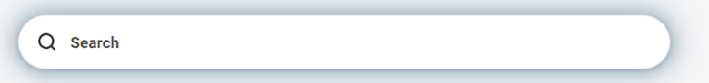
Click on the report as shown below.
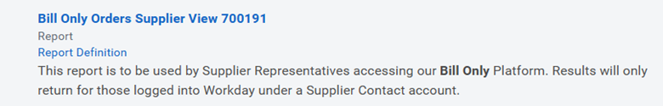
Company: Enter the applicable company
Request Date: Represent the date the requisition was created.

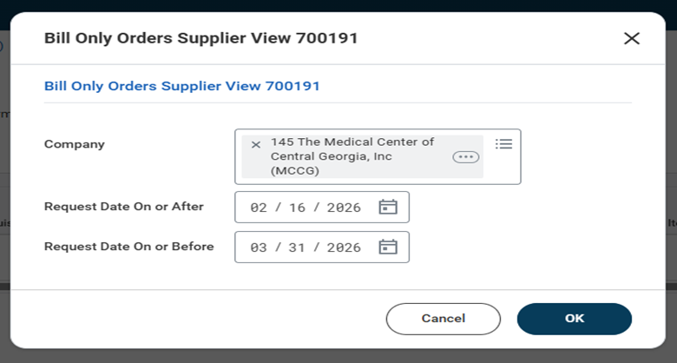
The table below will appear providing the information show plus more.
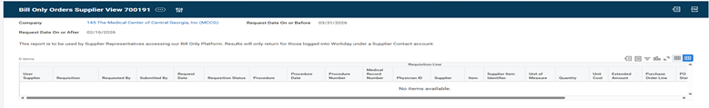

Appendix A: Support Expectations and SLAs
Last Updated: 09/10/2026

This appendix defines the service expectations, turnaround times, and support pathways for the Bill Only process. It is intended to set clear, shared commitments across Advocate Health teams (Vendor Management Office, Procurement, and Master Data) and our supplier partners so that support is timely, consistent, and auditable.

New Rep Account Setup — Turnaround Times
Once an Advocate Health teammate submits a new rep request to vmo@aah.org (with #billonly in the subject line), the following applies:

Step | Owner | Expected Timing
Build Supplier Contact in Workday after Salesforce request | Vendor Management Office (VMO) | 1–2 business days
Identify new Supplier Contact via reporting and enable portal access / security group | Workday Security Team | Triggered automatically by reporting; no handoff email required
Rep receives registration + "account ready" notification | System-generated | —
Total cycle time — initial VMO request to rep able to log in and process a requisition | End-to-end | 2–3 business days

Important — No manual handoffs required. When the VMO builds the initial Supplier Contact after receiving the request in Salesforce, they do not need to forward anything or send emails to any other team. Our reporting process naturally catches new Supplier Contacts within 1–2 business days and prompts the Workday Security team to complete the next step. This is by design — please do not create side emails to "push" a request along, as it does not accelerate the process.

Ongoing Support — Login, App, and Security Issues

Once a site has exited the go-live phase (loosely defined as the first two weeks following go-live), all login, app-access, and security issues must be handled through the ServiceNow Incident process. The pathway is:
- The supplier rep first contacts their site operations representative — the Advocate Health teammate who supports their location.
- The Advocate Health teammate enters a ServiceNow Incident. This is the only approved means of obtaining support for rep login, app, or security issues.
- The teammate tracks the Incident and communicates resolution back to the rep.

⚠️ Emails will be redirected. After the go-live period, any email sent directly to an individual teammate — or to VMO, Procurement, Master Data, or any other team — regarding login, app, or security issues will be professionally redirected to the ServiceNow Incident process. This ensures every issue is tracked, prioritized, and resolved consistently, and that nothing falls through the cracks.

Note: During the first two weeks of a site's go-live, teams may provide more hands-on, direct support to ease the transition. The ServiceNow Incident requirement takes effect once that window closes.

