Healthy Together 5210 Collateral and Information for Placing an Order
Year One: 5210 General Messaging
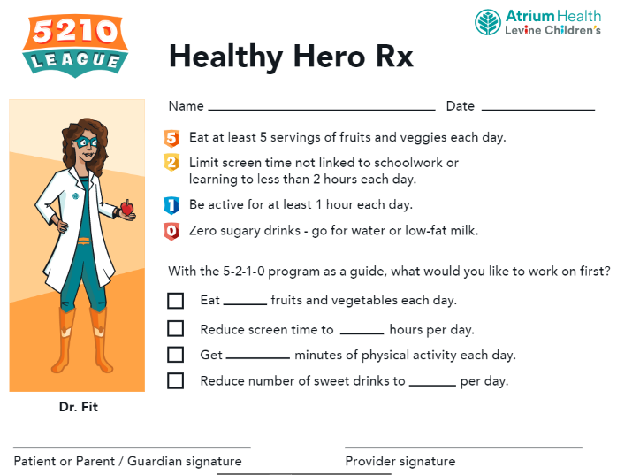
Rx Pad

One Pager (English and Spanish)
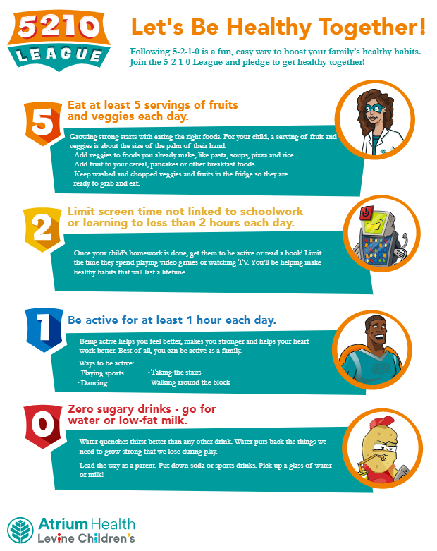

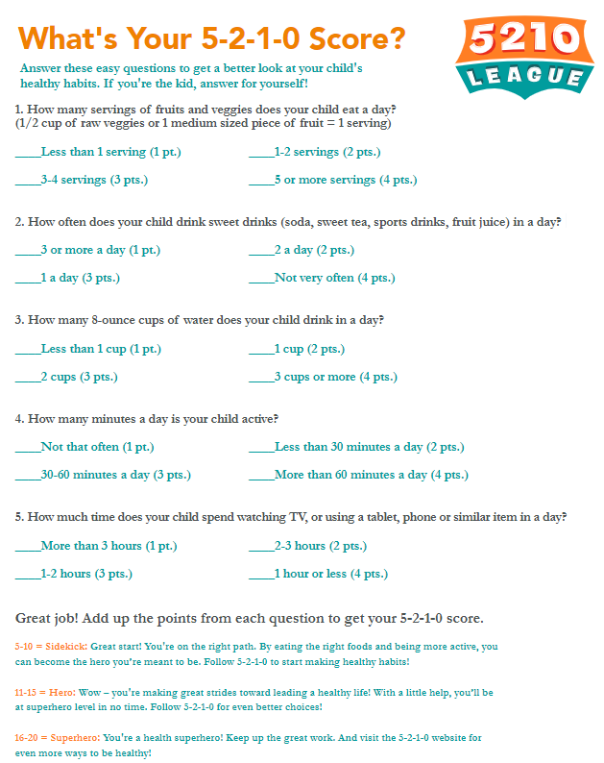
Quiz (English and Spanish)

Poster
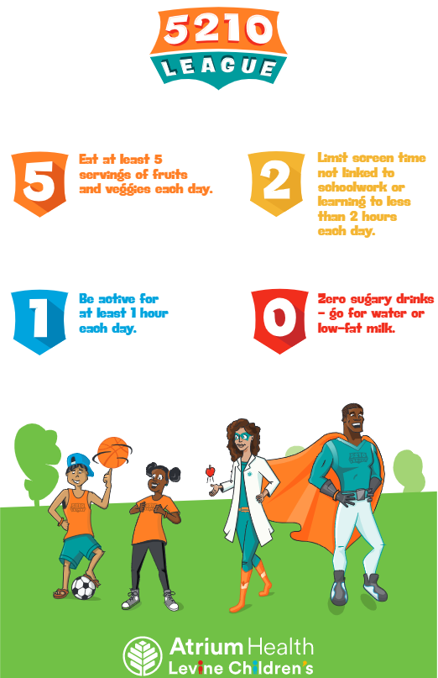

Year Two: Water (Zero Sugary Beverages)
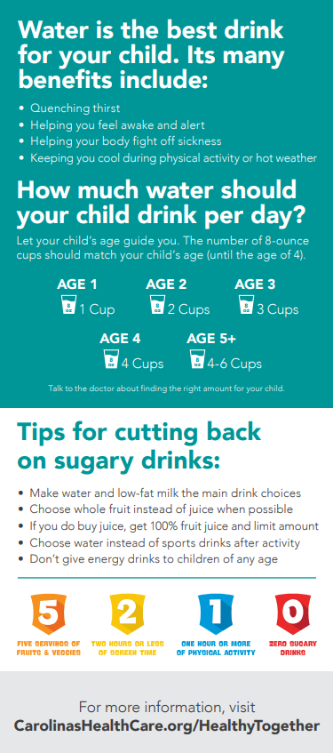
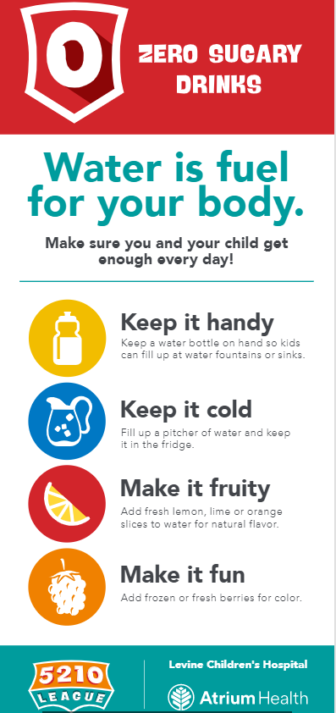
Water Rack Card (English and Spanish)

Water Bottle (9oz)*
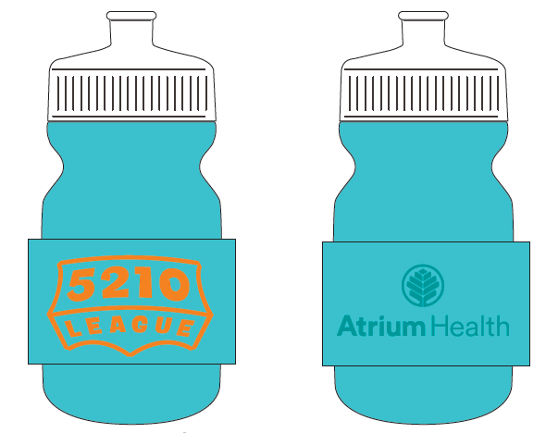
*Water bottle is ordered through Action Plus
Year Three: Fruits and Veggies
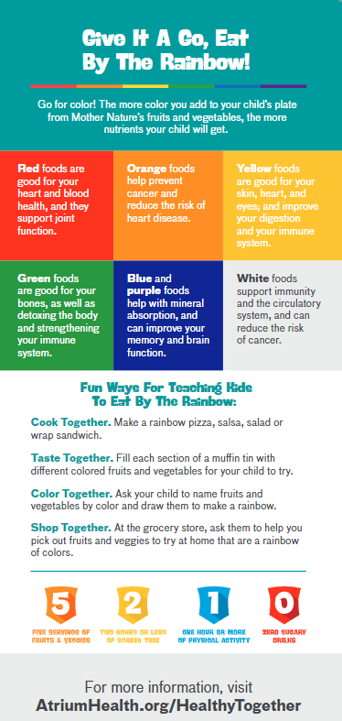
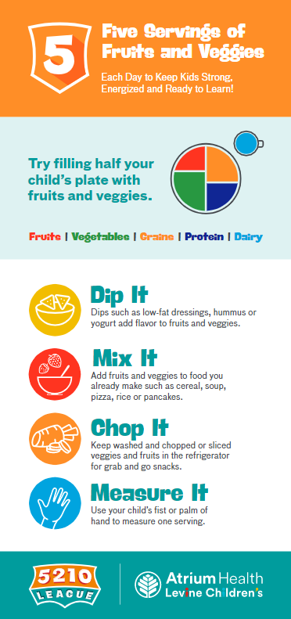
Fruits and Veggies Rack Card (English and Spanish)

Place Mat English & Spanish (Front) Place Mat English & Spanish (back)
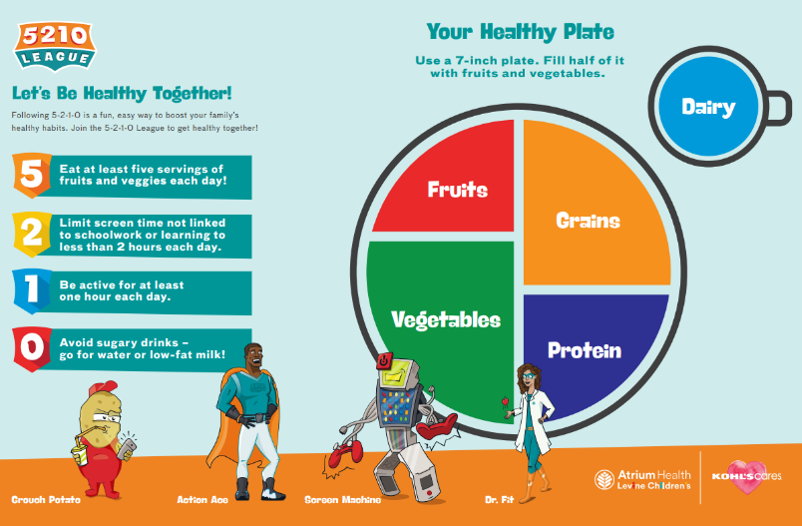
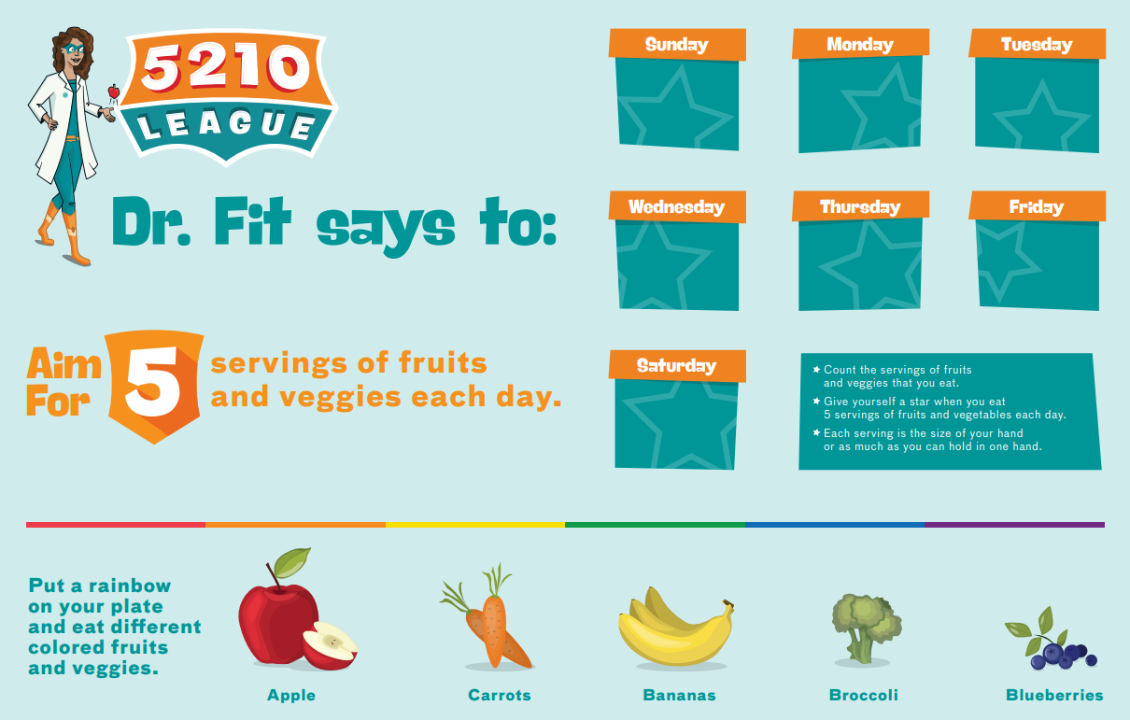

Other
Childhood Obesity Algorithm
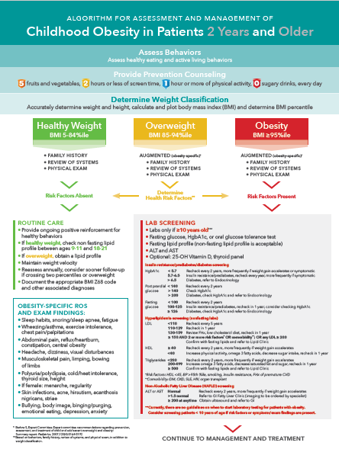
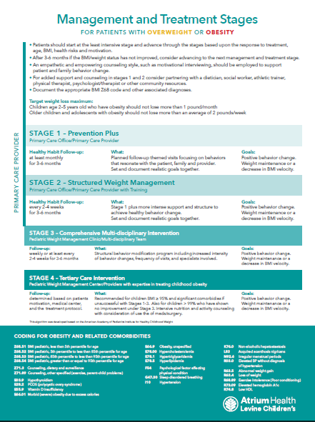

To order any of the educational materials above please contact:
Sid Wood at Boingo:
(704) 589-9138 or sid@boingographics.com

To order water bottles, please contact:
Helen Galatas Hinson at Action Plus:
(704) 536-8337 or Helen@actionplusideas.com

For Questions call Dan Fesperman in Community Benefit at 704-631-1006.

