Wake Forest Baptist Health
Training Center
AHA Course Roster - Effective 2025

Type of Course (Please check appropriate box):
☐ BLS Provider | ☐ ACLS Provider
☐ Heartsaver CPR in Schools (K-12)  Child and Infant and First Aid- optional | ☐ ACLS Update
☐ Heartsaver CPR AED  Child and Infant -optional | ☐ PALS Provider
☐ Heartsaver First Aid CPR AED  Heartsaver Total, Child and Infant-optional | ☐ PALS Update
☐ Heartsaver Pediatric First Aid CPR AED  Heartsaver Pediatric Total, Pediatric First Aid, Child/Infant, Adult CPR- optional | ☐ HEARTCODE BLS  (AHA Completion Certificate must be attached)
☐ Heartsaver First Aid | ☐ HEARTCODE ACLS  (AHA Completion Certificate must be attached)
☐ Family & Friends | ☐ HEARTCODE PALS  (AHA Completion Certificate must be attached)
☐ PEARS Provider | (Please indicate optional choices on evaluation)
All BLS, ACLS, & PALS Instructor Courses MUST have Prior Approval from Training Center Coordinator.
Only Training Center Facility can teach Instructor Courses.
☐BLS Instructor Course ☐ ACLS Instructor Course ☐ PALS Instructor Course

Course Date: Course End Date:
Course Start Time: Course End Time:
# of Participants: Student to Manikin Ratio:
Course Location:
Instructor Name | Lead or assisting | Instructor EMAIL
Do You Need Cards?  ☐ Yes, Number of Cards Needed  ☐ No  Payment: Amount ______________  ☐ Check enclosed Check ______________  ☐ Bill to:  __________________________  __________________________  __________________________ |  | Please make checks payable to:  Wake Forest Baptist Health-CTC Dept. 322205  Attn: Community Training Center  Medical Center Blvd  Winston Salem, NC 27157  Please email all typed rosters to: LifesupportedAHWFB@advocatehealth.org  (Mailed rosters will no longer be accepted)

Phone: (336) 716-9174 mail: lifesupportedAHWFB@advocatehealth.org Website: wakehealth.edu/tc

Participant Roster
Written test scores are required for BLS, ACLS, PALS Provider courses and all Instructor Courses. Pass or Fail is sufficient for Heartsaver Courses.
First Name | MI | Last Name | Telephone # | Email address | Score | Remediated Score (If Applicable)

Course Coordinator: Email Address: __________________________
Phone Number: Alternate phone number:
I verify that all information is accurate, truthful and may be confirmed. This course was taught in accordance with AHA 2025 Guidelines.

Course Coordinator Signature: Date:

American Heart Association
Basic Life Support Course Evaluation
Instructor Name(s):
Course Type (ex.HCP, HS, HS-AED, HS-Sch, F/F etc.):
Course Date(s): Course Time(s):
Please rate to what extent you achieved each of the following objectives during this course:
Upon completion of this course the participant will be able to: | Excellent | Good | Fair | Poor | N/A for this curriculum | Comments:
Provide proper ventilations using mouth-to-mouth, BVM (HCP only) and mouth-to-barrier device.
Verbalize indications for and demonstrate use of the AED for adult and pediatric victims.
Demonstrate the recovery/side position for unconscious victims.
Adult:
Demonstrate proper rates and techniques for one and two rescuers (HCP only) CPR.
Demonstrate choking/FBAO techniques for conscious and unconscious victims.
Demonstrate proper techniques and rate for rescue breathing (HCP only).
Child:
Demonstrate proper rates and techniques for one and two rescuers (HCP only) CPR.
Demonstrate choking/FBAO techniques for conscious and unconscious victims.
Demonstrate proper techniques and rate for rescue breathing (HCP only).
Infant:
Demonstrate proper rates and techniques for one and two rescuers (HCP only) CPR.
Demonstrate choking/FBAO techniques for conscious and unconscious victims.
Demonstrate proper techniques and rate for rescue breathing (HCP only).
Rate the Instructor’s Overall Presentation: | Excellent | Good | Fair | Poor |  | Comments:
How would you rate the instructor’s knowledge of the material?
Is there any additional instructional information you would like to see added to the course?
Include any Additional Comments on the back of this page:
Thank you for your interest in improving our courses.

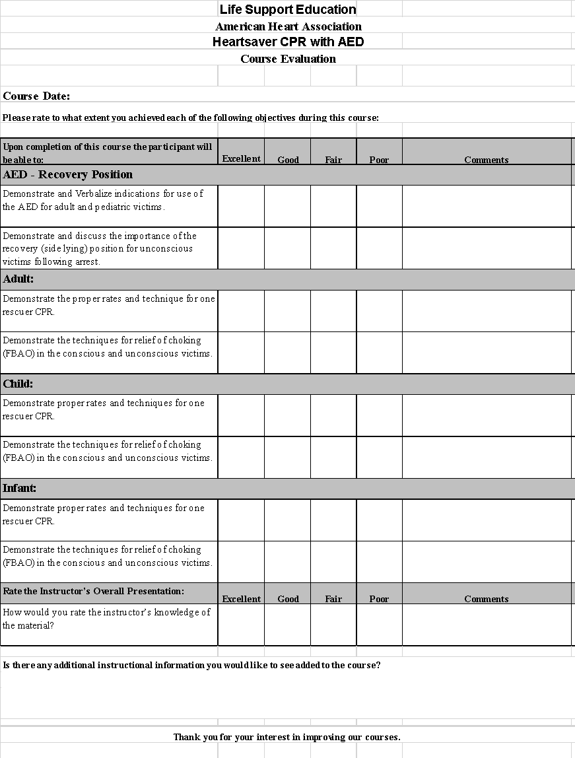This course was taught in accordance with AHA 2025 Guidelines

