Patient:  Gamunex-C 10%  (immune globulin injection [human]) |  |  |  |  |  | DOB:
**check appropriate box**
**All orders with ☒ will be placed unless otherwise noted**
Required lab results and/or tests prior to scheduling:
IgG level every 3 months, CMP every 6 months
ICD 10/Primary Diagnosis: |  |  |  |  | ICD10/Secondary Diagnosis:
Height: | Weight: |  |  |  | Allergies:
Infusion Therapy |  |  |  |  | Frequency
☐ Gamunex-C ______________gm IV over titratable rate  (dosing weight based on chart below) |  |  |  |  | ☐ ________________________________________________  ___________________________________________________  ☐Total number of doses: ___________________________________
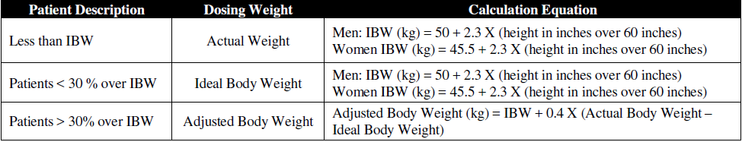
Dosing Chart:
Pre-Medication ☐ NO PRE-MEDICATION REQUIRED
Pre-medications administered 30 min prior to infusion
Medication |  |  | Dose | Route | Medication |  |  | Dose | Route
☐ Benadryl |  |  |  | IVP | ☐ Solu-Medrol |  |  |  | IVP
☐ Benadryl |  |  |  | PO | ☐ Tylenol |  |  |  | PO
☐ Loratadine |  |  | 10mg | PO | ☐
☐ Toradol  Given pre- or post- infusion per patient preference |  |  |  | IV | ☐
PRN MEDS:  ☐ Acetaminophen 500mg PO q4 hours PRN pain  ☐ Zofran 4mg IVP q4 hours PRN nausea/vomiting  ☐ Ibuprofen 800mg PO q8 hours PRN pain |  |  |  |  | PRN EMERGENCY MEDS:  ☒ Per Facility protocol  ☐ Provider requested Emergency Medication  ___________________________________________
Labs
☐ Labs drawn prior to scheduling infusion (results provided) – IgG level every 3 months, CMP every 6 months
Labs to be drawn treatment course by nurse: ☐ NO LABS REQUIRED (provider will send results)
LAB |  | FREQUENCY |  |  | LAB |  | FREQUENCY
☐ IgG (required) |  | Every 3 months |  |  | ☐
☐ CMP (required) |  | Every 6 months |  |  | ☐
Nursing Communication/Orders
Infusion Monitoring:
- Obtain vital signs pre- and post-infusion and every hour while infusing.
- Monitor for signs and symptoms of reaction for 30mins after initial infusion and subsequent infusions PRN.

