Patient:  PRIVIGEN 10% (IVIG)  CIDP |  |  |  |  |  | DOB:
**check appropriate box** **All orders with ☒ will be placed unless otherwise noted**
ICD 10/Primary Diagnosis: |  |  |  | Height: |  |  | Weight:
Allergies:
Infusion Therapy |  |  |  |  | Frequency
Privigen Immune Globulin Intravenous (Human), 10% IV  ☐ Loading Dose & Maintenance Dose  Dose: ____________________________________  ☐ Maintenance Dose Only  Dose: ____________________________________ |  |  |  |  | ☐ Single Infusion every ___________________________ weeks  ☐ Divided doses given on _______________ consecutive days  Every ______________________ weeks  ☐ Number of doses/Duration: ___________________________
Pre-Medication ☐ NO PRE-MEDICATION REQUIRED
Pre-medications administered 30 min prior to infusion
Medication |  | Dose | Route |  | Medication |  |  |  | Dose | Route
☐ Benadryl (diphenhydramine) |  |  | PO
☐ Tylenol (acetaminophen) |  |  | PO
PRN EMERGENCY MEDS:
☒ Per Facility protocol
☐ Provider requested Emergency Medication: _________________________________________________________________________
Labs
Labs to be drawn over treatment course by facility: ☐ NO LABS REQUIRED
LAB | FREQUENCY |  |  |  | LAB |  |  | FREQUENCY
☐ CBC |  |  |  |  | ☐ BMP
☐ IgG |  |  |  |  | ☐ Hemoglobin
Provider Communication
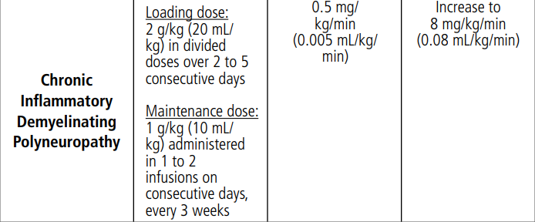

Recommended dosing and Administration:

- Monitor HGB post infusion in patients at risk for hemolysis, such as those receiving high doses (e.g., 2 mg/kg) and non-O blood group, underlying anemia, inflammatory state, cardiovascular or pulmonary compromise.
- Consider monitoring Sodium, serum viscosity, total protein post infusion; risk of Hyponatremia, Hyperviscosity.
- Rapid infusion should NOT BE USED in patients at risk for renal dysfunction or thromboembolic events (which includes the elderly, overweight or immobilized) or with hypertension, cardiovascular disease, dehydration, or thrombotic disorders.
- Increased risk of Infusion Reaction for patients with IgA deficiency.
- Patients predisposed to acute renal failure use, IVIG at the minimum concentration and at minimum rate of infusion practical.
Nursing Communication/Orders
Hold therapy and notify provider:
1. Creatinine is GREATER than ULN
2. Signs of dehydration
3. IgA Deficient
4. VTE
Monitor vital signs every 15 minutes until maximum rate is reached, then hourly.

