**Nuestra Familia Sana**

**Genomics Educator Program**

**Educator Training Manual**

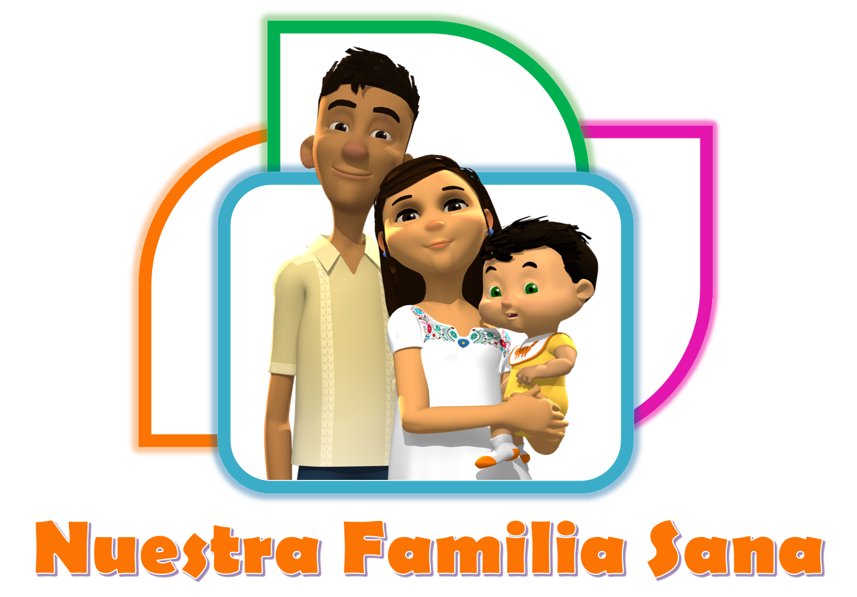

Any opinions, findings, and conclusions or recommendations expressed in this material are those of the authors and do not necessarily reflect the views of the National Science Foundation.

**Developed by:**

**Grisel Trejo, MPH1**

**Timothy D. Howard, PhD1**

**Sara A. Quandt, PhD1**

**Thomas A. Arcury, PhD1**

**DaKysha Moore, PhD2**

**Joanne C. Sandberg, PhD1**

1 Wake Forest University School of Medicine

Winston-Salem, NC 27157

2 John R. and Kathy R. Hairston College of Health and Human Sciences

North Carolina Agricultural and Technical State University

Greensboro, NC 27411

This material is based upon work supported by the National Science Foundation under Grant No. 1612616

**For information contact:**

Joanne C. Sandberg, PhD

Wake Forest University School of Medicine

Medical Center Boulevard

Winston-Salem, NC 27157

336-716-4308

jsandber@wakehealth.edu

**Copyright 2021**

**Wake Forest University School of Medicine**

**Suggested citation:** Trejo G, Howard TD, Quandt SA, Arcury TA, Moore D, Sandberg JC. *Nuestra Familia Sana*: Genomics Education Program. Educator Training Manual. Winston-Salem, NC: Wake Forest University School of Medicine, 2022.

**Training Manual Table of Contents**

**Introduction** ……………………………………………………………………. Page 3

**Section 1. Program Basics**

1. Introduction To The Program Page 6
2. Purpose of the Program Page 6
3. Principles Page 7
4. Confidentiality Page 7

**Section 2. All About Educators**

1. What is a Lay Community Educator? Page 12
2. Expectations of a Nuestra Familia Sana Educator Page 12
3. Professionalism Page 13
4. Recruiting Learners Page 14
5. Personal Safety Page 15
6. Personal Health Page 16

**Section 3. Genomics Basics**

1. What is a cell? Page 20
2. How is all genetic material stored? Page 21
3. What is a Gene? Page 22
4. Relationship between DNA and genes? Page 22
5. Mutations Page 23
6. Cell Communication Page 24
7. Fertilization Page 25
8. Epigenetic Changes Page 27
9. Genetic Risk Page 29
10. Putting it all Together Page 30

**Section 4.**  **Environmental Exposures Basics: The Hook**

1. Structure of Lessons Page 34
2. Environmental Exposure Modules Page 35

**Section 5. Teaching Basics**

1. Teaching Tips to Facilitate Learning Page 38
2. Keeping Learners Involved Page 39

**Section 6. Special Situations**

1. Child Abuse And Neglect Page 42
2. Suspected Domestic Violence Page 43
3. Suspected Drug Abuse Page 43
4. Signs Of Depression Page 44

**INTRODUCTION**

The Nuestra Familia Sana Genomics Educator Program (Our Healthy Family) is a community model of informal genomic learning that is culturally and linguistically appropriate for low-literacy Latinx adults. It was developed and implemented by a research team at Wake Forest University School of Medicine (WFUSM) with expertise in genomics and public health education. To engage learners who may have little knowledge or interest in genetic and genomics, we paired information about concrete strategies to keep families healthy by reducing environmental exposures with genetic and genomic content. Latinx adults have high interest in topics that will improve their families’ well-being. Therefore, we used that interest as a hook to encourage their participation in a set of learning opportunities about a STEM topic that many people without a strong science background find intimidating. Latinx community members provided the learning sessions in people’s homes or at local, trusted community organizations to further reduce intimidation.

Latinx adults in the United States (US) are often underrepresented in informal STEM learning opportunities. Access to such opportunities is particularly limited for Latinx immigrant adults who have limited formal education and lack English fluency. In the US, 55% and 47% of adult immigrants from Mexico and Central America respectively have less than a ninth grade education; 26% have a high school education (both regions); and 17% and 8% respectively, have a college education.1, 2 More Latinx individuals were born in the US than before, driving up English proficiency among teens and young adults (76%), but only around 55% of Latinx ages 34 to 49 report speaking English “very well.”3 In addition to potential language barriers and limited formal education, many Latinx immigrant adults in the US face additional challenges for engaging in informal learning, including limited financial resources, lack of documentation, language, transportation, perception that the programs or organizations such as museums are not for people like them, and lack perception of themselves as science learners.4, 5

Lay health educators, or educators, are recognized as an effective means to deliver health information and health services to Latinx. They have been found to be an effective way to extend existing health service delivery and to provide culturally competent services for minority, immigrant, and marginalized populations that have particular needs.6, 7 This project uses strategies similar to those used by lay health educators, but in the context of informal STEM learning. Lay Community Educators (LCEs) have knowledge about their community, have existing social connections, and minimize trust barriers.

**References**

1. Budiman A. Key findings about U.S. immigrants. Pew Research Center, Washington, D.C. [Internet] 2020 Aug 20. [cited 2022 Feb 01]. Available from: https://www.pewresearch.org/fact-tank/2020/08/20/key-findings-about-u-s-immigrants/
2. Noe- Bustamante L. Education levels of recent Latino immigrants in the U.S. reached new highs as of 2018. Pew Research Center, Washington, D.C. [Internet] 2020 April 7. [cited 2022 Feb 02]. Available from: https://www.pewresearch.org/fact-tank/2020/04/07/education-levels-of-recent-latino-immigrants-in-the-u-s-reached-new-highs-as-of-2018/
3. Krogstad JM. Rise in English proficiency among U.S. Hispanics is driven by the young. 2016. Washington, D.C.: Pew Research Center; 2013.
4. Sacco K, Falk JH, Bell J. Informal Science Education: Lifelong, Life-Wide, Life-Deep. Plos Biology. Nov 2014;12(11).
5. Stein JK, Garibay C, Wilson KE. Engaging immigrant audiences in museums. Museums & Social Issues. 2008:3(2), 179–196.
6. Martin C. Reducing Racial and Ethnic Disparities: Quality Improvement in Medicaid Managed Care Toolkit. Hamilton, NJ: Center for Health Care Strategies, Inc.; 2007.
7. Kim S, Koniak-Griffin D, Flaskerud JH, Guarnero PA. The impact of lay health advisors on cardiovascular health promotion: using a community-based participatory approach. J Cardiovasc Nurs. 2004:19(3);192-199.

1

**PROGRAM BASICS**

**PROGRAM BASICS**

**Introduction to the Program**

Welcome to the *Nuestra Familia Sana* Genomics Program. During training, you will be given the information necessary to perform effectively as an educator. The training will include information on what a lay educator is, how to accomplish the duties of an educator, a brief overview of the five environmental factors to be addressed, how they affect family members’ health, a detailed overview of genetic and genomic topics, and how to handle administrative procedures. At the end of the training, you will be given the opportunity to practice each step in being an effective *Nuestra Familia Sana* educator and leader in your community. Practice will include role-plays, games, and completion of administrative paperwork.

You are encouraged to participate and be active during the training to ensure that the training program is effective in preparing you for the lessons. The staff will observe, listen, and give feedback during the practice sessions. You are encouraged to ask questions you may have during the training session. The staff wants to prepare you fully for completing the educator duties.

**Purpose of the Program**

The primary goal of the *Nuestra Familia Sana* program is to provide informal learning opportunities to Latinx adults with limited English, and often-limited formal education, about genomics. The program also aims to advance their interest in and knowledge about complex genetic and genomic concepts in a culturally and linguistically appropriate manner. Furthermore, it is designed to increase their interest in science more generally and to advance their confidence in their ability to learn about science. The program has the added benefit of teaching learners about how to reduce their families’ contact with five different negative environmental exposures, thereby allowing the learners and their families to be healthier now and in the future. This program may also develop leadership skills of Lay Community Educators and builds the capacity of community members to improve their communities.

**Principles**

* Community members have the power to make positive changes within their own communities.
* Community members have legitimate knowledge that must be respected.
* It is important to expand the public’s understanding about science.
* Everyone should be provided with culturally and linguistically appropriate opportunities to learn about science topics, and in a manner that is appropriate for their educational background.
* People learn when they feel respected and trust the person guiding the learning process.
* Learning about genomics should be fun.

**Confidentiality**

Trust is essential to the *Nuestra Familia Sana* program. An important element of trust is confidentiality. Nothing you discuss with any learner in the *Nuestra Familia Sana* programshould be discussed with anyone other than the learner or members of the staff. You should never discuss any information about a learner with any other person, even if you do not reveal the name. Keep all information in a safe place where no one else can find and read it. Make sure the learners know that their information will be kept confidential.

It is easy to break confidentiality. Sometimes you do not even realize that you are doing it. Please read the following story below.

Rosa’s Story

Rosa is a very friendly and sincere person and has all the characteristics of a good educator. In her passion to help, she found herself in a situation in which she was not sure what to do. As Rosa was doing her community educator work, she arrived at the home of a woman who was participating in the program. Entering the home of Elena, Rosa was impressed by how pretty her house was decorated. They began talking about the importance of protecting unborn children and infants from pesticide exposure, which was the topic for that month. During the discussion, it became clear to Rosa that Elena’s family was not in need of anything; they had more than what they needed to nourish themselves.

Continuing with her monthly visits, Rosa arrived at the very humble and simple home of Marta. During the course of the nutrition lesson, Marta, looking very worried, told the educator that she did not have enough food for her young child that day. Rosa, wanting to know more about Marta’s situation, asked Marta a series of questions. A very interesting story emerged. Marta told Rosa that she had loaned money to Elena, a friend of hers, because poor Elena did not have any money and Marta did at the time. Elena had promised to pay her back, but she had not paid her anything back yet. Marta thought that Elena was doing better and was able to pay her back, but she was not sure…

**Discussion Questions:**

1. How do you think Rosa felt in this situation?
2. What do you think Rosa should do in this situation?
3. What would be the best way for Rosa to help Marta with her problem of needing food?
   1. What would you do?
4. What would happen if Rosa told Marta what she had seen in Elena’s house that morning?
   1. If Rosa did tell Marta what she had seen in Elena’s house, how would this affect the relationship between Elena and Marta?
   2. How would it affect the *Nuestra Familia Sana* program?

2

**ALL ABOUT EDUCATORS**

**COMMUNITY EDUCATORS**

**What is a Community Educator?**

Community educators are persons who provide important information to other members of their community. They are trained in various education approaches. Community educators use their training as a resource for the larger community and they help to identify and address potential problems that may hinder the learners’ abilities to learn. They also use their knowledge about their community to diagnose and respond to local conditions so the learners are able to freely interact with the materials/information presented and reach the program’s goals.

**Expectations of a Nuestra Familia Sana Educator**

As a community educator for the *Nuestra Familia Sana* program, you will help families in your community learn about genetics and genomics while also learning about how to keep their family safe from environmental exposures.

By attending the education classes with us, you will be able to use what you have learned to help center visitors, your neighbors, family, and friends in many important ways.

You will not be a nurse or health professional, but you will have important information that can help other families take better care of their health. Over the next weeks, you will:

* Attend education classes: You are expected to attend training sessions where you will learn information and techniques to be an effective community educator.
* Visit people and share information: You are expected to visit with each of your learners about once a week (or more depending on preferences of your organization) to teach them what you have learned in your education sessions. The information you will present will help learners gain knowledge about genomics and environmental exposures.
* Keep in touch with your supervisor: Let the supervisor know about any questions, problems, or concerns that you might encounter while working in your community.
* Keep good records: The work you are doing as a community educator is important, so we want to know about all the learners that you talk with and what you talk about. We will discuss all forms that you should complete and give to the supervisor.
* Keep information confidential: Since you will be working with the community, people will share some of their problems and stories with you as they get to know you better. It is very important that you do not share this information with anyone else.

**Professionalism**

* Leadership: Know that you are an example and will be watched closely in your community. Try to practice all methods that you teach to lead your community by example.
* Home visits: Please always show up to your appointments. If you cannot complete your visit, let them know in advance so they will not be expecting you.
* Present materials: Present all materials that you are given for the learners. If you find you are running out of time and you are not able to extend your stay, reschedule another time to complete the lesson. Please be aware that some learners may not be able to read or write in English or Spanish. Therefore, leaving materials for learners to read may not be appropriate.
* Communicate effectively: When speaking to the learner, hold eye contact, speak clearly but pleasantly and always check for learner understanding.
* Dress professionally: Dress in a way that portrays you as a knowledgeable community leader. Avoid wearing clothing with large labels, clothing that is tight, or any type of athletic wear.
* Problem solving: If you find yourself with a problem that you cannot solve, please contact your supervisor so she/he can help you reach the best solution possible.
* Cultural competency: Although the majority of the learners will be Latinx, there will be variations in backgrounds and religions. Please be careful not to offend anyone with any demeaning comments. Generally, if you speak in a positive and encouraging way, you will likely not be offensive. If you do happen to offend a learner, apologize.
* Recording information accurately: Remember when you are recording information always try to be accurate in recording the learner’s responses. Write as clearly and neatly as possible. Always include detailed observations in your notes. You can never write too much.

**Recruiting Learners**

You will find your own individual style of recruiting learners to be a part of the *Nuestra Familia Sana* program. You will approach people differently depending on their personalities and your relationship with them. Some people are going to be very interested in learning more about protecting their family from environmental exposure. Others are going to need convincing that participating in the program is worth their time.

As you interact with people, you need to remember for someone to qualify as a “learner” he/she needs to be:

*Specific to each organization*

As you are recruiting learners, always remember: **You are the expert in your community.**

**Discussion Questions:**

1. Where are the kinds of places you can go in your communities to find people to participate?
2. If you find someone who is not sure that they want to participate, how can you convince them that the *Nuestra Familia Sana* program will be worthwhile?

Note: It is important not say that this program is intended to teach about genetics and genomics at first, as to not to intimidate potential learners

**Personal Safety**

If the lessons will be delivered outside of the organization, educators should follow some basic safety guidelines. If the educator or organization does not know the learner or was not referred to them by a trusted contact who knows them, the lessons could be taught in safe local community spaces that are conductive to learning, such as libraries or parks.

Traveling to unfamiliar places to meet people (some of whom you do not know) can be uncomfortable. It is important that you feel safe and secure at all times while teaching lessons outside of the organization. To help you become more comfortable with the ever-changing work environment, be aware of your surroundings when in the community and note any unusual occurrences. If you feel that your personal safety is compromised at any point, remove yourself from the situation and contact the supervisor immediately. Examples of unsafe situations are listed below but use your best judgment. Leave the vicinity immediately in these situations:

* If the learner threatens you verbally or physically.
* If someone other than the learner is threatening you or creating an unsafe situation.
* If any weapon is displayed in an unsafe manner or a manner that makes you uncomfortable.
* If you suspect any sort of abuse.
* If you pull onto the learner’s street or driveway during an unsafe situation, for example, fighting or unusual crowds of people.
* If you are sexually threatened or harassed by the participant or others in the community.
* If there are aggressive dogs or other hostile animals in your immediate area or that have access to you.
* If there is threatening weather that may pose a risk or danger to driving, for example severe thunderstorms or hurricane-like conditions.

**Personal Health**

Please keep in mind that the learners’ and the educators’ health is very important to this organization. To stay safe and prevent any spread of COVID-19 or other diseases, such as influenza, please follow these guidelines:

* When necessary or appropriate, teach lessons in large indoor spaces with good ventilation.
* If you are at a learner’s home and the weather is appropriate, you may ask to deliver the lessons outside on the porch or driveway. A portable table and chair will be necessary for this.
* Lessons during the COVID-19 era should only take place with one learner, with multiple eligible adults living within the same household, or learners who are already comfortable being with each other.
* Educators, participants and others present should wear a facemask during the lessons. If participant does not have a mask, please provide one.

Prior to any in-person learning session, the educator will be required to ask learners the following questions:

* Have you had a fever, cough, or shortness of breath, vomiting or diarrhea in the last 7 days?
* Have you had contact with someone who was diagnosed to have COVID-19 in the last 10 days?
* The educator is required to ask herself the same questions. If the learner and the educator respond negatively to all questions, she may proceed with scheduled in-person visit. Otherwise, lessons should be rescheduled for at least 10 days.

3

**GENOMIC**

**BASICS**

**GENOMIC BASICS**

**Cell, DNA and Genes**

This section will cover all the science concepts in the lessons. This section gives more information and details than what will be presented to the learners, but it will assure that you will be able to answer simple questions learners may ask.

What is a Cell?

All living things are made of cells. Cells are the most basic unit of life. Some living organisms, like simple bacteria, are made of just one cell. Most other living things are made of billions or trillions of specialized cells.

Cells are very small structures that are usually only seen through a microscope. Cells are small structures that make up our bodies. The cells that make up different parts of the body look different from each other. For example, there are different types of cells that make up the heart, lung, and brain. All cells have specialized jobs that are specific for the organs in our bodies.

Most human cells contain a nucleus. A nucleus is the compartment in the cells that contains our genetic information in the form of DNA.

Note: red blood cells and blood platelets are human cells without a nucleus. This means that these cells do not have our genetic information.

Nucleus

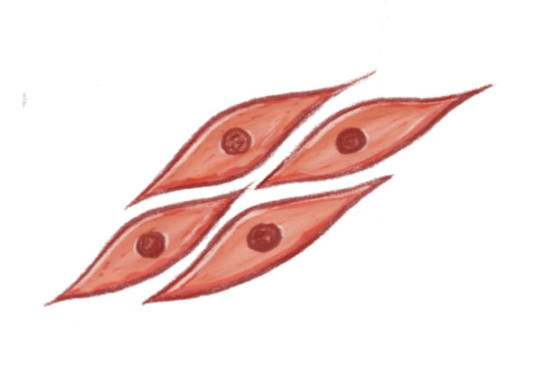

Muscle cells

Let’s learn! Cell hands-on activity!

How is all Genetic Material Stored?

DNA stands for deoxyribonucleic acid. DNA is the genetic material in humans and all other organisms. Almost every cell in a person’s body has the same DNA inside the cell nucleus. The information stored in the DNA (“genes”) is responsible for the development and function of an organism.

In cells, DNA is arranged in structures called chromosomes, and each chromosome consists of one long strand of DNA. The information in DNA is stored as a code made up of four chemical bases: adenine (A), guanine (G), cytosine (C), and thymine (T). The order of the bases determines the information that the cells use to make and maintain an organism. Think of the way in which letters of the alphabet create specific words depending on the order in which they are placed.

DNA bases pair up with each other in a certain pattern to form units called base pairs. Base pairs are arranged in two long strands that form a spiral called a double helix. The structure of the double helix looks similar to a twisted ladder as seen below.

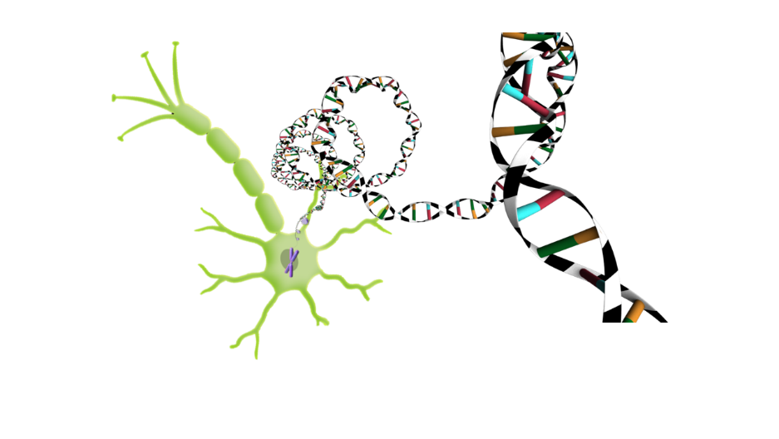

What is a Gene?

Genes are made up of smaller sections of DNA. Some genes act as instructions for the cell to function. Humans have approximately 25,000 genes in each cell. All cells that have DNA contain the same genetic information.

One gene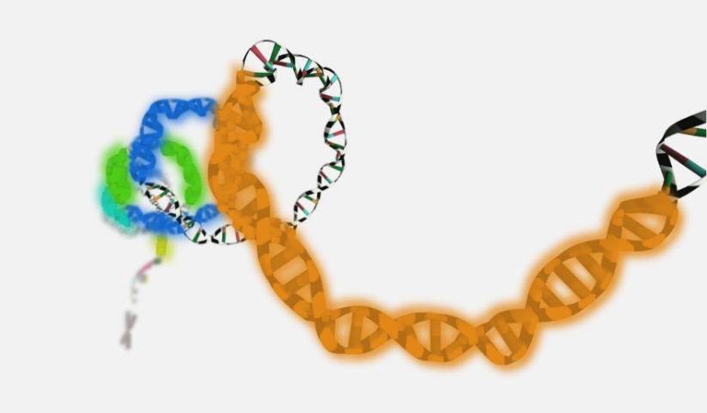

If all cells have the same genetic information, how do cells become different? Cells do not use all of their genetic information available. Each set of cells uses a unique combination of genes to become that particular cell type. For example, cells in the heart only use a certain gene combination, allowing them to become heart cells and work in the way a heart needs.

Most genes are the same in all people. A very small percentage of genes (~0.3%) are slightly different from person to person. The combination of small differences in a person’s genes is one thing that makes each person unique.

Relationship between DNA and Genes

* All of our body parts, like the skin, eyes, lungs, and brain, are made of different type of cells. Each cell type is specialized in doing a different job in our body.
* Here we see the brain, which contains mostly brain cells, also called neurons.
* Inside the cell, we can see a nucleus.
* Inside the nucleus are small chains of DNA that contain all of the person’s genetic information. Every cell in this person’s body has the same DNA.
* Some parts of the DNA form genes. Genes are instructions that tell the cells what to do so the body can function.

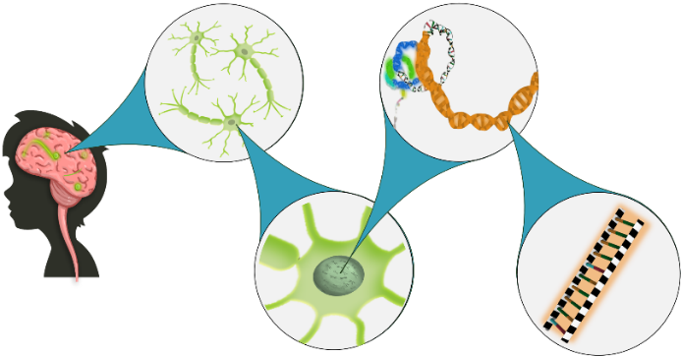

**Mutations**

* Genes are codes that provide the instructions for everything the cell does. Genes usually do not change. When a change occurs in the DNA sequence, the gene undergoes a mutation. A mutation is a change in one or more parts of a gene.
* Mutations can occur naturally (mostly due to mistakes when the DNA is copied), but mutations are more common when the cells are exposed to certain chemicals like those found in cigarette smoke or environmental exposures like the sun’s ultra violet (UV) light.
* Often, mutations do not cause a problem, but sometimes they can lead to diseases, as the cell is no longer able to continue its normal function. Think about how changing a letter in a word (rod > pod) would make it have a different meaning.
* Below is an example of a base pair (red and blue) taking the place of a different base pair (green and yellow). This mutation disrupts the original sequence of the gene. This change may cause the cell to reproduce uncontrollably, leading to cancer. Not all mutations lead to disease.
* Most mutations are permanent.

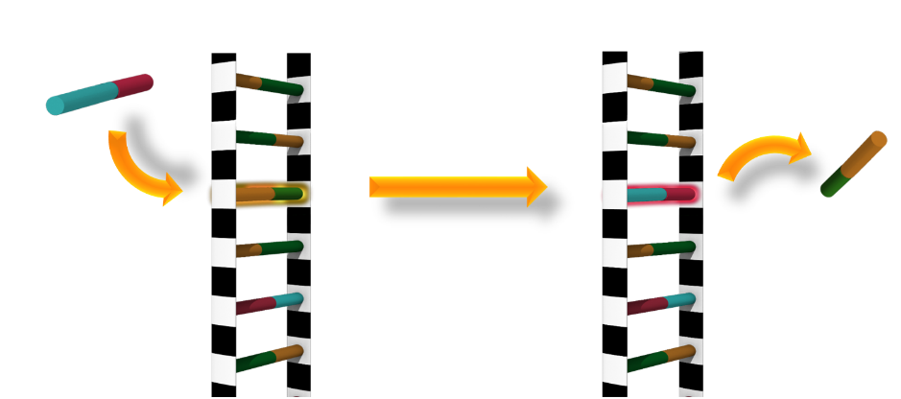

**Cell Communication**

* We learned that environmental exposures such as secondhand smoke or UV light could affect our genes and cause mutations. Some substances, like lead, can also cause harm, even without affecting our DNA or genes.
* Our brain cells, called neurons (also called nerve cells), need to talk to each other for all of our bodily functions, such as sensing temperature, moving your muscles, or thinking. They communicate by sending and receiving chemical signals.

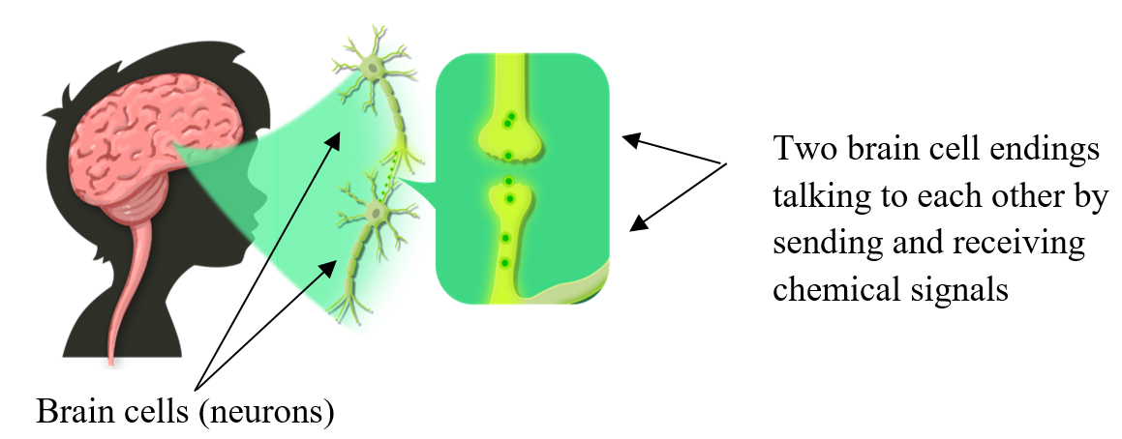

* Some chemicals like lead, harm brain development in children by disrupting normal communication between brain cells. Cells in the brain need to communicate with each other to function correctly. Lead keeps cells from talking to each other correctly. When a child has been exposed to lead, the connections between brain cells do not work correctly. Abnormal cell communication can also cause problems when adults are exposed.

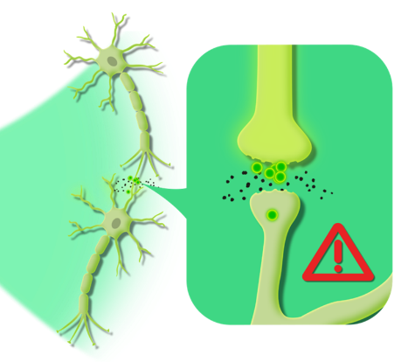

**Fertilization**

* We learned that almost all cells contain a person’s genetic material in the form of DNA. Males make sperm for reproduction, but unlike the other cells, sperm only contain exactly half of the male’s DNA. All sperm are different. Every sperm contains a different and random mix of the male’s DNA.
* Females have eggs, each of which also contain exactly half of their DNA. Like the sperm, each egg contains a different and random mix of her DNA.
* Below we see a man’s genetic material (half from his father in dark blue and half from his mother in light blue). To the left is his sperm, which is a random (and mostly unequal) mix of his genes.
* We also see a woman whose eggs are also a random mix of her genes (half from her father and half from her mother).

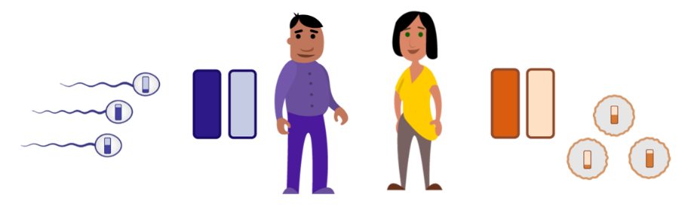

* Fertilization happens when an egg and a sperm join together. A fertilized egg contains all the genetic information it needs to become a baby. That baby has half of his or her genes from each parent.

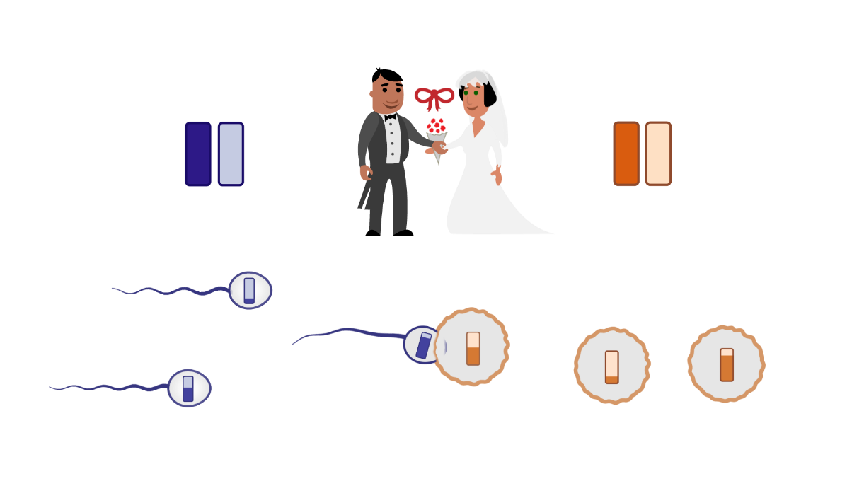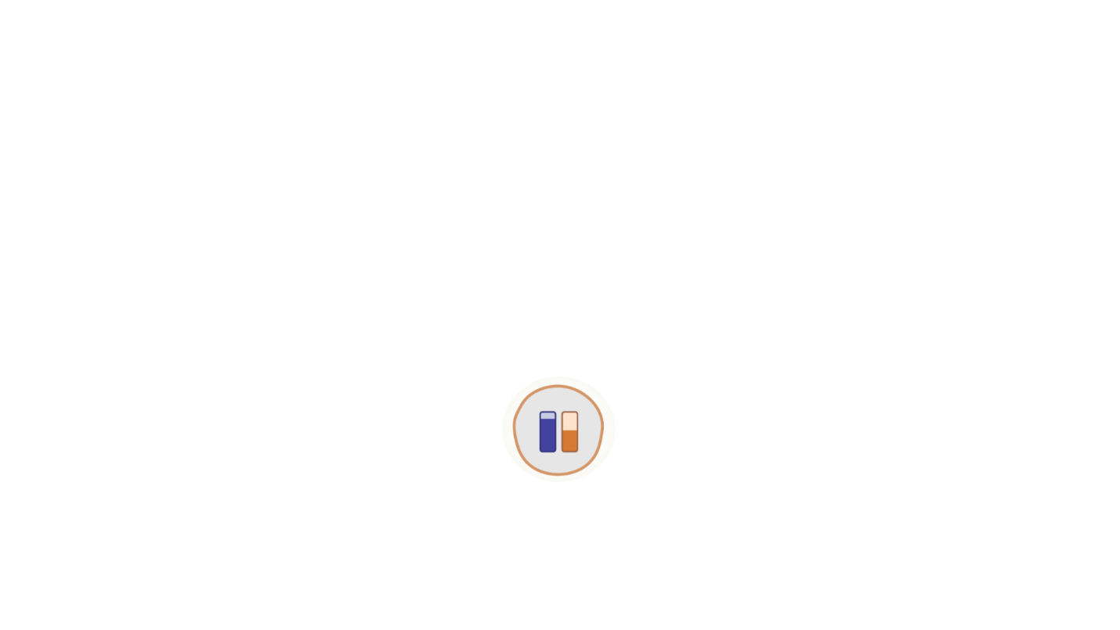

Siblings

* Siblings sometimes look a lot like each other and sometimes they have very different characteristics or physical appearances. Siblings look like each other because they share some of the same genes. On average, they share 50% of their genes.

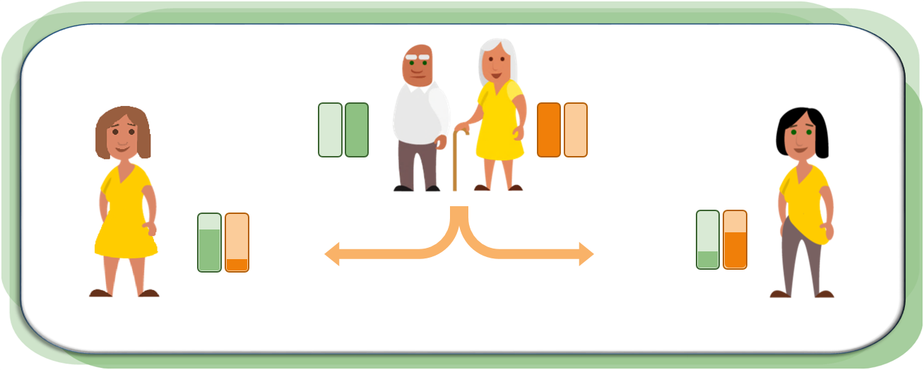

Fraternal Twins

* Fraternal twins are not identical and look like any other siblings.
* Normally, a mother releases only one egg per month, but sometimes she can release two or more eggs. Fraternal twins are formed when two different sperm fertilize two different eggs at the same time.
* Fraternal twins do not share the exact same DNA. They can be the same or different sex (male and male, female and female, male and female).
* Below we can see an example of one pregnancy with fraternal twins.

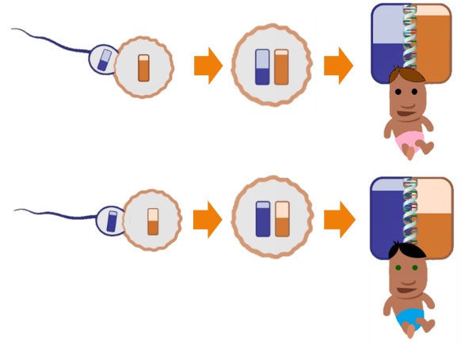

Identical Twins

* Identical twins are unique as they form from a single egg fertilized by a single sperm.
* Soon after fertilization, the fertilized egg splits into two exact copies.
* Identical twins share the same DNA; therefore, their genes are nearly identical.
* Identical twins look the same or almost the same. Identical twins are always the same sex (male and male, or female and female).

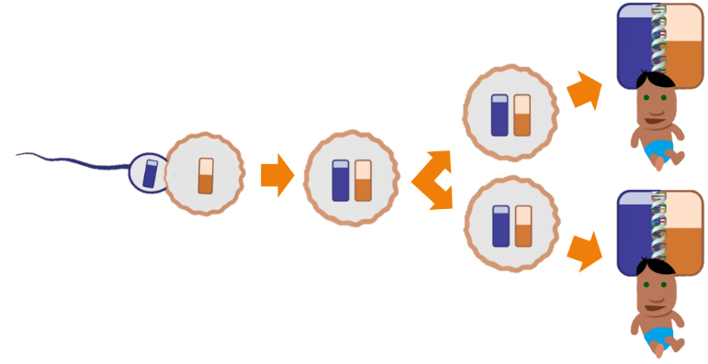

**Epigenetic Changes**

Each cell in a person’s body, with few exceptions, has the same DNA. Genes are contained in the strands of DNA. This means that each cell in a person’s body has the same genes. But we know that different types of cells look and function differently from each other. Muscle cells in the heart look and function differently from nerve cells in the brain. This is because different sets of genes are turned on and off in heart and nerve cells.

* A gene is inaccessible to the cell when a segment of the DNA containing that gene is tightly wound or closed. The instructions contained in that gene cannot be found or accessed. The gene is turned off.
* When the DNA containing a gene is loosely wound or open, the gene is accessible. The instructions contained in that gen can used. That gene is turned on.

Epigenetics is the study of how cells control gene activity (i.e., turning on and off) without changing the DNA sequence in a gene. Epigenetic changes are modifications to DNA that regulate whether genes are turned on or off.

* + Epigenetic changes that cause DNA to become tightly wound close or turn off genes.

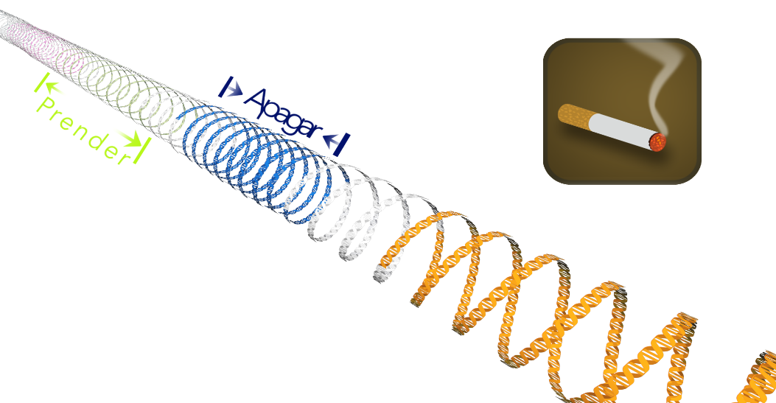

* + Epigenetic changes that cause DNA to loosen open or turn on genes.

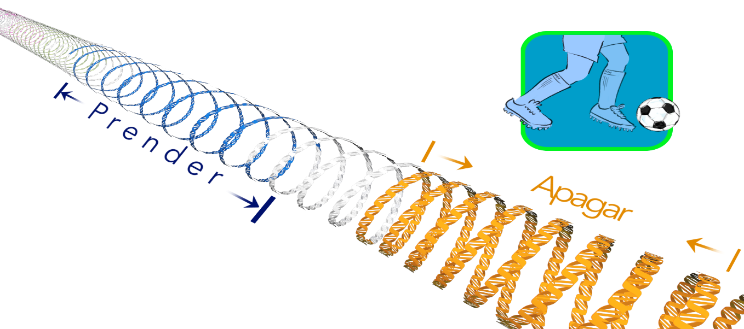

Why does it matter if a gene is open or closed?

* The instructions in genes that are open can be accessed or used. The instructions in genes that are closed cannot be accessed or used. Cells work best when certain genes for that cell are turned on and certain genes are turned off.
* An epigenetic change either makes a strand of DNA more tightly wound, or makes a strand of DNA less tightly wound.
* If a gene that is usually open becomes tightly wound up or closed due to an epigenetic change, the cell is unable to use or access that gene. On the other hand, when a gene should be closed and an epigenetic change opens the gene, the cell may not be able to perform its specific role correctly. Therefore, epigenetic changes can lead to abnormal gene activity.
* Epigenetic changes do not change DNA or genes themselves. Epigenetic changes alter whether genes are accessible or used (i.e., turned on or off).
* Epigenetic changes can cause better health or contribute to negative health conditions.
* Some epigenetic changes can be temporary, and some can be permanent.
* Behavioral influences and environmental exposures, such as a person’s diet, can cause epigenetic changes.
  + Examples of environmental exposures: exposure to secondhand smoke or Bisphenol-A (a chemical widely used in plastics). (NOTE: Secondhand smoke can also cause mutations.)
  + Examples of habits or behaviors: diet, exercise, or smoking. (NOTE: Smoking can also cause mutations.)

**Genetic Risk**

* We learned that children, regardless of their sex, inherit half of their genes from mom and half from dad. With those genes, they inherit physical traits, as well as chances of getting some diseases.



* In this picture, we see that the mother has two copies of her genes. She passes down one-half of her genes to the child. The father also passes down one-half of his genes. In this example, this baby received a gene or genes associated with a risk of developing a disease from the father. Because this child carries a gene associated with a disease, he is more at risk of developing this disease than someone without that gene.
* For most common diseases, however, inherited genes alone do not determine the cause.
* Many diseases, including type 2 diabetes, are caused by a combination of the environment, genes, and behaviors. Genes are just one part of the puzzle.
* Having a family member with a disease means that there is an increased risk for having that disease, compared to someone without a family history.
* Having an increased risk means that a person is more likely to get the disease than someone else is. But, having an increased risk does not mean that the person will definitely develop it.

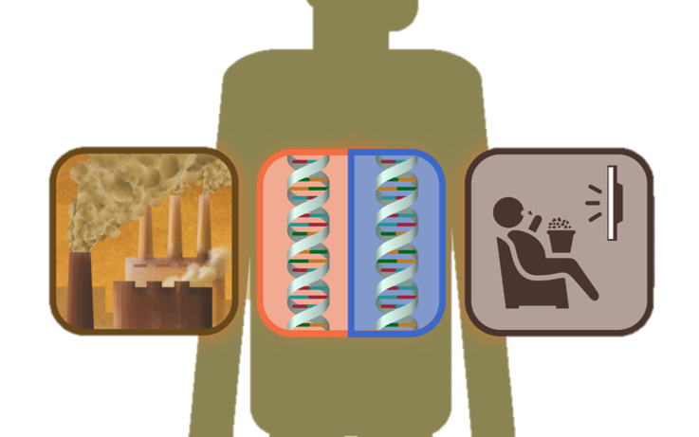

**Putting it all Together**

Important terms:

* + DNA: DNA is genetic material stored inside every cell. The information stored in the DNA is responsible for the development and function of an organism.
  + Genes: Genes are made up of smaller sections of DNA. Some genes act as instructions for the cell to function. All cells that have DNA contain the same genetic information specific for that person or organism.

We have learned that behavior, chemicals, and substances in the environment affect the body differently.

* First, some chemicals and some substances in our environment can change genes.
  + Mutations are changes to parts of the DNA. Mutations are mostly permanent. Mutations can occur naturally, but chemicals in our environment can make them occur more often.

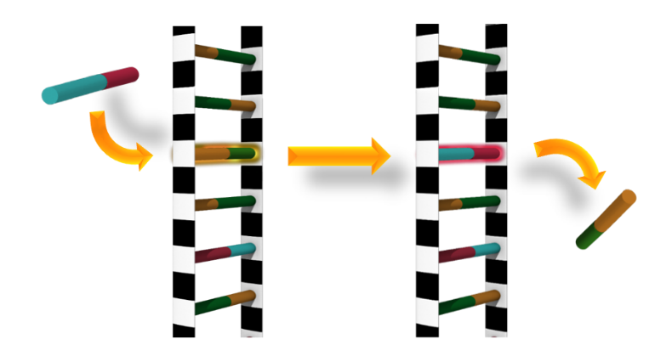

* A second way chemicals and behaviors can affect health is by changing how genes work, without causing mutations.
  + Epigenetic changes can turn some genes on and other genes off. Some epigenetic changes can be harmful and some beneficial. Some epigenetic changes are temporary and some are permanent.

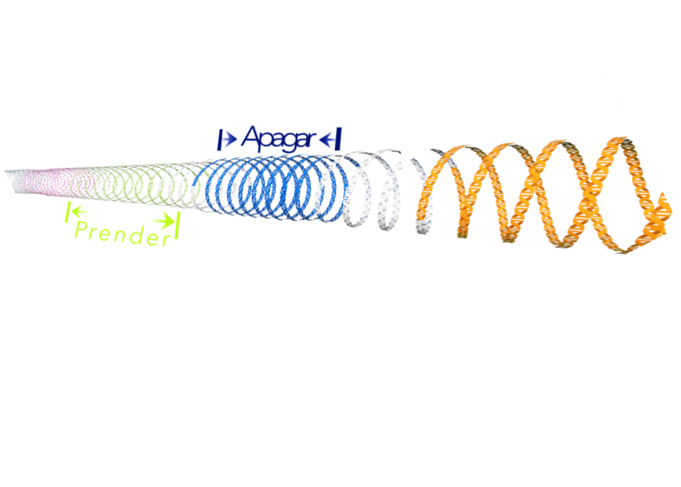

* There is also a third way chemicals and substances can affect health without affecting DNA or genes.
  + Sometimes chemicals and substances can disrupt the normal processes of cells without affecting the genes. Lead, for example, prevents normal brain development. Lead interferes with the communication between cells in the brain, affecting the way cells work.

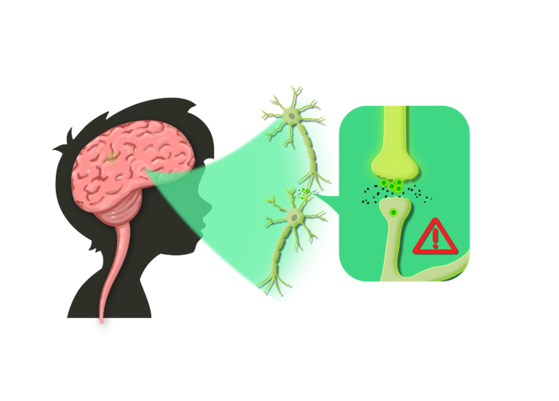

* Lastly, inheritance also plays a role in determining health.
* A few diseases are purely determined by genes, but many diseases, including type 2 diabetes, are caused by a combination of the environment, genes, and behaviors.

**Other Resources**:

If you have access to a computer or tablet, you can show the following interactive graph to get a sense of the size of a human skin cell (in pink) relative to a grain of rice or coffee bean.

Note: this interactive activity is only in English.

* https://learn.genetics.utah.edu/content/cells/scale/

Other Spanish and English resources:

* https://www.genome.gov/es/About-Genomics/Introduccion-a-la-genomica
* https://www.genome.gov/genetics-glossary/c#glossary

Other English-only resources:

* Studying cells from NIH

https://www.nigms.nih.gov/education/fact-sheets/Pages/studying-cells.aspx

* Help Me Understand Genetics

https://medlineplus.gov/genetics/understanding/

https://medlineplus.gov/genetics/understanding/basics/dna/

4

**ENVIRONMENTAL EXPOSURES: THE HOOK**

**ENVIRONEMTAL EXPOSURES: THE HOOK**

**Lessons Structure**

The *Nuestra Familia Sana* Program is composed of five lessons. Every lesson teaches a different subject. This section will review the environmental information for each lesson. The subjects for each lesson are:

* **Lesson 1**: Secondhand Smoke
* **Lesson 2:** Lead
* **Lesson 3:** BPA
* **Lesson 4:** Nutrition
* **Lesson 5:** Pesticides

Each lesson is broken into five sections:

* 1. *Video* - introduces all the content of the lessons
  2. *Background* – introduces the environmental topic
  3. *Health effects* - gives an overview of the possible health effects from the exposure
  4. *Learning science* - gives an overview of the genetics and genomic concepts. The science component is not always in the same order.
  5. *Behavior change* – gives learners concrete ways to reduce exposure to environmental component.

**Print and add the environmental sections of the flipcharts here**

5

**TEACHING**

**BASICS**

**Teaching Tips to Facilitate Learning**

* It is important to be prepared for the lesson. The lesson plan has a list of materials needed for that particular lesson.
* Avoid presenting the information by reading the text from the flipchart. Learn the information and use the text as a guide. Learners will engage and learn better with eye contact.
* We want to help participants retain knowledge they gain during the sessions. Therefore, it is important to ask participants questions throughout the sessions about concepts related to genomics that they have already learned about – and to wait for their responses. Through the process of recalling information addressed previously during the sessions, they will develop stronger, more durable memories about genomics (and how to keep their families healthy).6 It is therefore important to use the question prompts, engage participants in discussion, and have them participate in the activities.
  + Ask open-ended questions, that is, questions that do not have a yes or no as an answer. For example:
    - What was not clear about this section? *Open ended*
    - Was there something that was not clear in this section? *Closed ended*
* Set an appropriate pace for learning that fits each learner.
* Do not assume high literacy levels. This program is designed to fit learners with low literacy levels.
* Invite other members of the family to learn together (if appropriate).
* Maximize the learning environment (lighting, distractions, time of day, etc.).
* Avoid giving additional information not presented in the text (unless provided by the organization).
* Learners will probably ask questions you cannot answer. That is okay. Do not try to answer questions if you do not know the answer. Let the learner know that you will try to get an answer. Refer to the Frequently Asked Questions guide or ask your supervisor after the lessons.
* Do not give medical advice.

**Keeping Learners Involved**

It is important to keep learners interested and enthusiastic about the lessons and your visits. Let’s discuss how we can achieve this.

**Discussion Questions** (and possible responses)**:**

1. How do you think that you can keep people interested in participating and finishing the program?
2. If you were one of the learners, what would help you look forward to a visit from a community educator?
3. What kind of information would people be most interested in?

If learners want to know more about science topics, consider creating a list of useful resources in your community, like children’s museums or science centers. For additional information about genetics and genomics, useful websites are also included in page 31 of this manual and in the Frequently Asked Questions document.

In addition, many people may be interested in health-related topics; therefore, they may start asking questions about health topics that educators are not able to answer. If this happens, please direct learners to ask their doctor or healthcare provider. The job of the educator is to maintain the participant’s interest in the content of the lessons.

6

**SPECIAL**

**SITUATIONS**

**SPECIAL SITUATIONS**

**Child Abuse and Neglect**

Child abuse is a situation with which you should be familiar when working with families. Although you are not in people’s homes as a social service agency or law enforcement official, we all have some responsibility to help children who may be in danger. We will define what constitutes child abuse, and indicate our program’s guidelines for dealing with suspected instances. Please keep in mind that the following are guidelines and not policies on how to recognize signs of child abuse and what to do if you come across them.

Child abuse can happen in many different ways, but the result is serious physical or emotional harm. Physical or sexual abuse may be the most striking types of abuse, since they often leave physical evidence behind. However, emotional abuse and neglect are serious types of child abuse that are often more subtle and difficult to spot. The following are signs of child abuse.

* **Physical signs:**  Sometimes physical abuse has clear warning signs, such as unexplained bruises, welts, or cuts. While all children will take a tumble now and then, look for age-inappropriate injuries, injuries that appear to have a pattern such as marks from a hand or belt, or a pattern of severe injuries.
* **Behavioral signs:**  Signs of physical abuse may be more subtle. The child may be fearful, shy away from touch or appear to be afraid to go home. A child’s clothing may be inappropriate for the weather, such as heavy pants and long sleeved shirts on hot days.
* **Caregiver signs:**  Physically abusive caregivers may display anger management issues and excessive need for control. Their explanation of the injury might not ring true, or may be different from an older child’s description of the injury.

**Child neglect is** the most frequent form of child abuse. Neglect is a pattern of failing to provide for a child's basic needs or endangering a child’s physical and psychological well-being. Child neglect is not always deliberate. Sometimes, a caregiver becomes physically or mentally unable to care for a child, such as in untreated depression or anxiety. Other times, alcohol or drug abuse may seriously impair judgment and the ability to keep a child safe. The result, however, is a child who is not getting their physical or emotional needs met. The following are warning signs of child neglect.

* Physical signs: A child may consistently be dressed inappropriately for the weather, or have ill-fitting, dirty clothes and shoes. They might appear to have consistently bad hygiene, like appearing very dirty, matted and unwashed hair, or noticeable body odor. Another warning sign is untreated illnesses and physical injuries.
* Behavioral signs: Does the child seem to be unsupervised? The child might show troublesome, disruptive behavior or be withdrawn and passive.

Reporting Suspected Child Abuse and Neglect

In many states, all adults are mandatory reporters of suspected child abuse or neglect. Remember, it is not your responsibility to decide if something you observe is child abuse or neglect. However, it is your responsibility to report any signs of possible abuse or neglect. Reporting child abuse seems official. Many people are reluctant to get involved in other families’ lives. However, by reporting, you can make a tremendous difference in the life of a child and the child’s family, especially if you help stop the abuse early. Early identification and treatment can help mitigate the long-term effects of abuse. If the abuse is stopped and the child receives competent treatment, the abused child can begin to regain a sense of self-confidence and trust. Some parents may also benefit from support, parenting training, and anger management. If you ever feel that a child is being abused, contact your supervisor to discuss the situation. She/he will be able to follow-up on the situation.

**Suspected Domestic Violence**

Domestic violence is another area with which we should all be familiar. Domestic violence occurs between partners in a relationship. Examples of abuse include:

* Name-calling or putdowns
* Keeping a partner from contacting family or friends
* Withholding money
* Stopping a partner from getting or keeping a job
* Actual or threatened physical harm
* Sexual assault
* Stalking
* Intimidation

If you suspect domestic violence, discuss this with your supervisor and she/he will decide what the best steps are to help that learner in their situation.

**Suspected Drug Abuse**

If you suspect that one of your learners or a member of his/her family is using or abusing drugs, report this directly to the supervisor. Some signs or symptoms of drug use are:

* Unusual calmness, unresponsiveness or looking “spaced out”
* Apathy and depression
* Paranoia, delusions
* Temporary psychosis, hallucinations
* Suspected drug paraphernalia such as unexplained pipes, roach clips or syringes
* Lowered threshold for violence
* Abnormally slow movements, speech or reaction time, confusion and disorientation (often seen in users of opiates, benzodiazepines and barbiturates)

If you see these signs and are concerned about one of your learners or a member of his or her family, we will be able to provide them with information about receiving help.

**Signs of Depression**

Depression is an illness that involves the body, mood, and thoughts. It affects the way a person eats and sleeps, feels about himself/herself, and thinks about things. A depressive disorder is not the same as a passing blue mood. Someone with depression usually feels very sad and sometimes does not know the reason why. The following are symptoms/signs of a depressed person:

* Persistent sad, anxious, or "empty" mood
* Feelings of hopelessness or pessimism
* Feelings of guilt, worthlessness, or helplessness
* Loss of interest or pleasure in hobbies and activities that were once enjoyed, including sex
* Decreased energy, fatigue, or being "slowed down"
* Difficulty concentrating, remembering, or making decisions
* Insomnia, early-morning awakening, or oversleeping
* Appetite and/or weight loss, or overeating and weight gain
* Thoughts of death or suicide; suicide attempts
* Restlessness or irritability

If you suspect that a participant of yours is depressed, report this to the supervisor. Although you are not there to identify medical conditions of the learners, if we see that they need other services, we want to link them to the services that may help them.